

HERE TO LISTEN: OUR SAFEGUARDING TEAM

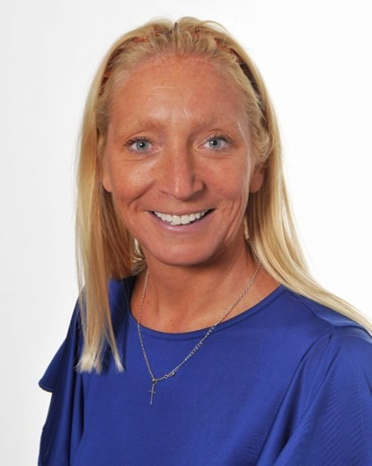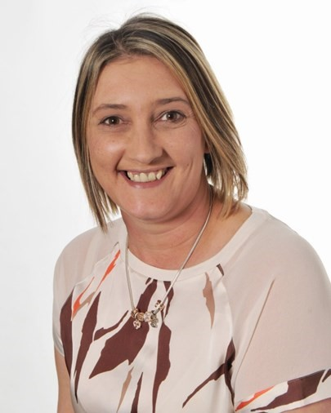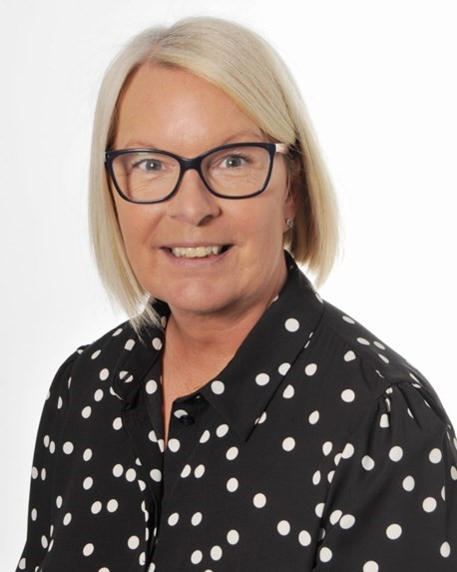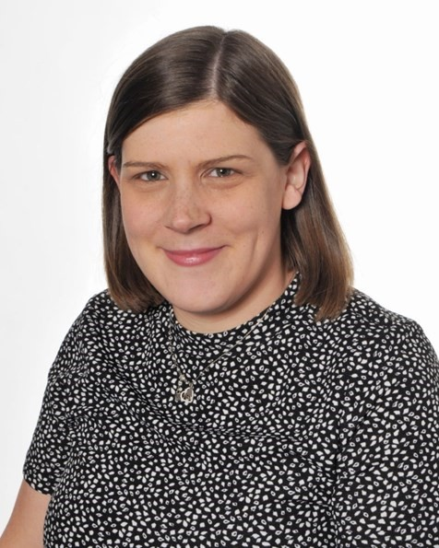

Designated Safeguarding Lead:

Ms Sara Richardson

Contact details:

head@st

-

michaelangels.lancs.sch.uk

Deputy Designated Safeguarding Lead:

Mrs Michelle Coffey

Contact details:

m.coffey@st

-

michaelangels.lancs.sch.uk

Are you concerned about the safety or wellbeing of a child?

If so please contact one of our safeguarding team.

Deputy Designated Safeguarding Lead:

Mrs Rebbecca Lamb

Contact details:

r.lamb@st

-

michaelangels.lancs.sch.uk

-

You can also speak to

Mrs Wendy Phillipson,

a member of our senior leadership team

sbm@st

-

michaelangel.lancs.sch.uk

**Out of hours Contacts**

Emergency Duty Team: 03001236722

Or Childline on 08001111

If you are concerned about the immediate

safety of a child, call 999

