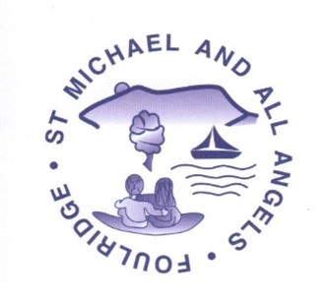
St Michael and All Angels CE VA School
Long Term Planning 2023-24
“Working Together to achieve our best, we listen, love and learn through Christ”

Intent:
At St Michael and All Angels, our Early Years Foundation Stage curriculum is delivered by highly skilled practitioners who are creative, reflective and have the highest expectations for all children. We provide a happy, nurturing and supportive environment founded on the principles of the Christian faith; helping to develop children’s spiritual growth and moral understanding as well as their academic development.

Our team in Reception all have an excellent understanding of early childhood pedagogy and are constantly developing their knowledge, skills and understanding to ensure that we are laying the foundations for future learning to build upon. Our aim is for children to work together to do their best, whilst we listen, love and learn through Christ.

The learning environment at St Michael and All Angels plays a pivotal role in ensuring that our children experience a calm, home-from-home environment to explore their curiosities which build upon the children’s prior learning and home experiences.
Our children and staff build positive relationships through a key-person system, this ensures that the children feel safe, happy and valued. The staff work alongside parents and carers to ensure that children are challenged and develop a natural curiosity about the World around them.

Our curriculum is based on the prime areas of learning with an emphasis on
Communication and language, high-quality texts and questioning, reflecting the needs of our children. Children’s interests are incorporated into all areas of provision, to allow them to explore their own learning and fascinations, whilst sitting alongside the planned curriculum design and faith values of the school. You will see child-led learning whereby practitioners move learning on through in-the-moment scaffolding and nurture, ensuring that all children thrive. This consistent approach throughout our EYFS has ensured that our children develop a thirst for learning that continues as they progress through school.

Long Term Overview – Implementation of the Curriculum
 | Autumn 1  (7 weeks) | Autumn 2  (8 weeks) | Spring 1  (5 weeks ) | Spring 2  (6 weeks) | Summer 1  (6 weeks) | Summer 2  (7 weeks)
EYFS Theme | Happy to be Me! | Let’s Celebrate | Kings & Queens  Jack frost etc | Down at the Bottom of the Garden | Brilliant Beasts | Happy Holidays!
Topic Intent – why this topic? | As the children start on their educational journey in a new setting, we want to develop their sense of self and understanding of belonging to our school and church community. The children will also begin to recognise seasonal changes in the natural world around them. | We want our children to develop an understanding and respect for faiths, traditions and celebrations from around the world, feeding into our school and Christina values. | As we move through to the new season, we are focussing on changes over time. We continue with celebrating key events such as Chinese New Year and Lent. We also want our children to learn all about our country, including it’s capital city, in line with our British values. | We want children to appreciate the natural world right on their doorstep. Understanding what animals live within our locality and their impact on the environment. We are focussing on planting and growing. | Understanding the World is our focus this half term. We are searching our surrounding natural world and looking into habitats needed to support British wildlife.  Link to History and geography- meeting | This half term we are focussing on the wider world. We are looking further afield than our local area.  We are also beginning to get ready for transitioning to Year 1.
Predictable Interests | Birthdays, Autumn, Harvest, Farm | Bonfire Night, Diwali, Hanukkah, Remembrance Christmas - Nativity | Winter, Chinese New Year, Pancake Day – lent? | Spring, Easter, Eid, St George’s Day, Life cycles, Lent? | Summer, seasons, holidays, outdoors, | Transport  Sea Creatures  The beach
Enrichment  E.g. visit, visitor author, poet etc. | Local area  Local area walk | Cenotaph  Church Visit | Church Visit | Church visit.  Supermarket visit | show  Minibeast visit.  UTW – role in society visitor | Blackpool/Sea Life Centre  Manchester Airport (24/5)  Barlick Beach
Parental Involvement | Parent Workshop - | Parent Workshop – Phonics?  Parent’s Evening | Parent Workshop | Parent Workshop | Parent Workshop – art  UTW – role in society visitor | Parent Workshop
Religious Education
RE (Diocese of Blackburn scheme of learning)  Questful R.E | EYFS 2 Harvest  Why do people of faith say thank you to God at Harvest time?  (4)  Christian Concept  GOD – CREATION – Fall – People of God – Incarnation – Gospel – Salvation – Kingdom of God  Link To World Faiths  EYFS 1 I am Special  Why are we all different and special?  (5+1)  Christian Concept  GOD – CREATION – Fall – People of God – Incarnation – Gospel – Salvation – Kingdom of God  Link To World Faiths  Islam  EYFS 4 Christmas  How do Christians Celebrate Jesus’ birthday?  (4+2)  Christian Concept  God – Creation – Fall – People of God – INCARNATION – Gospel – Salvation – Kingdom of God  Link To World Faiths  Why do Hindus light candles at Diwali? | EYFS 5: Stories Jesus heard  Which stories did Jesus hear when he was a child?  (4)  Christian Concept  God – Creation – Fall – PEOPLE OF GOD – Incarnation – Gospel – Salvation – Kingdom of God  Link To World Faiths  EYFS 6: Stories Jesus Told  Why did Jesus tell stories?  (4)  Christian Concept  God – Creation – Fall – People of God – Incarnation – GOSPEL – Salvation – Kingdom of God  Link To World Faiths  EYFS 7: Easter  Why do Christians believe that Easter is all about love?  (5)  Christian Concept  God – Creation – Fall – People of God – Incarnation – Gospel – SALVATION – Kingdom of God  Link To World Faiths  Palm Sunday  Ash Wednesday | EYFS 9 Special Places  What makes a place special/holy?  (4+2)  Christian Concept  GOD – Creation – Fall – People of God – Incarnation – Gospel – Salvation – Kingdom of God  Links to World Faiths  Special Holy Places  Islam - mosques  EYFS 11 Special Times  (4+2)  Christian Concept  GOD – Creation – Fall – People of God – Incarnation – Gospel – Salvation – Kingdom of God  Links to World Faiths  Special Times  Islam, Judaism, Hinduism

Prime Areas of Development
Communication and Language
Linked Theme Texts  A bank of familiar texts/ traditional tales will be read daily to the children at story time. This will enable them to orally re-tell popular texts and stories independently. | Once there were giants, Little Glow by Katie Sahota, Kipper’s Birthday, Spot’s Birthday Party Rosie’s Walk, The Leaf Thief, Pumpkin Soup, The Very Helpful Hedgehog, Goodbye Summer, Hello Autumn, The Body Book by Hannah Alice. Squash and a squeeze, On the Farm, Farmer Duck, The Little Red Hen, Oi Frog  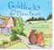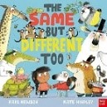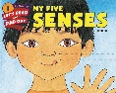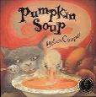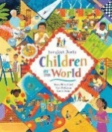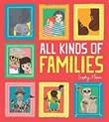 | Rama & Sita story, The Christmas Story, Worship with me at the Mandir, The Best Christmas Present Ever by Ben Mantle, Little glow, I don’t like winter (Fiona barker)  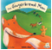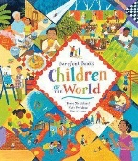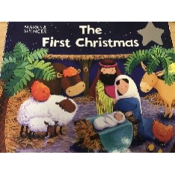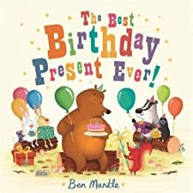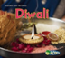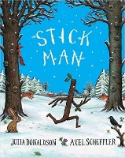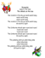 | The Runaway Pancake, Goodbye Winter, Hello Spring, Jack Frost, Once upon a snow storm, Rabbit’s Pancake Picnic (Teagan Evans) I Love Chinese New Year, Lunar New Year Around the World, Cinderella, The Emperor’s New Clothes   | 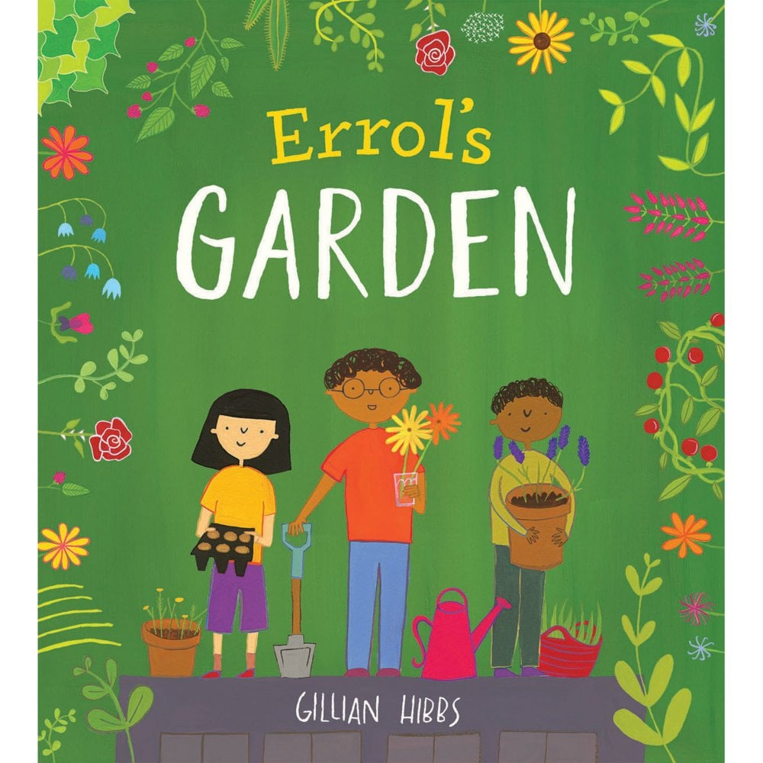  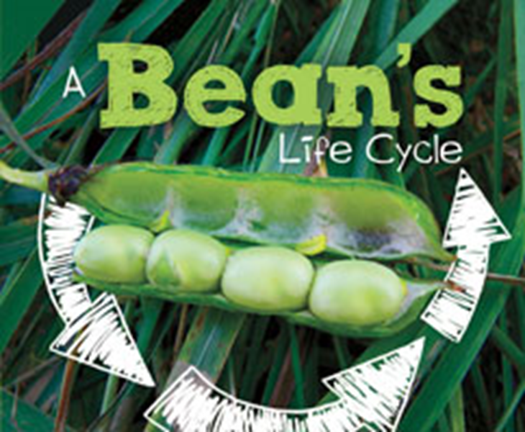  One Spring Day, Sam Plants a Sunflower, The Tiny Seed, The Great Eggscape, We’re Going on an Egg Hunt, The Easter Story, The Most Exciting Eid, In My mosque, Tad,  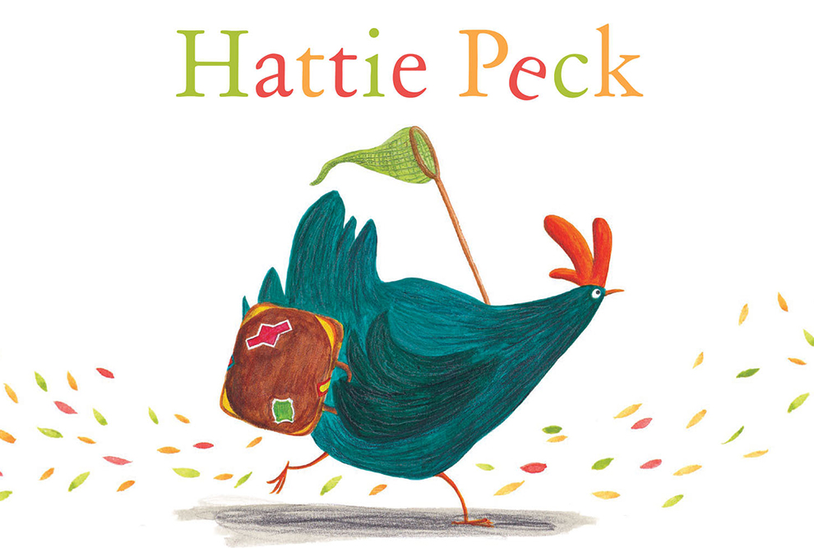  life cycles- growing beans, life cycle of a fog/chicken  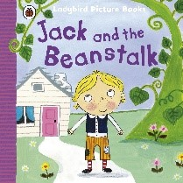  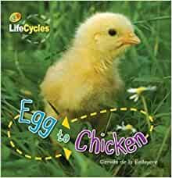  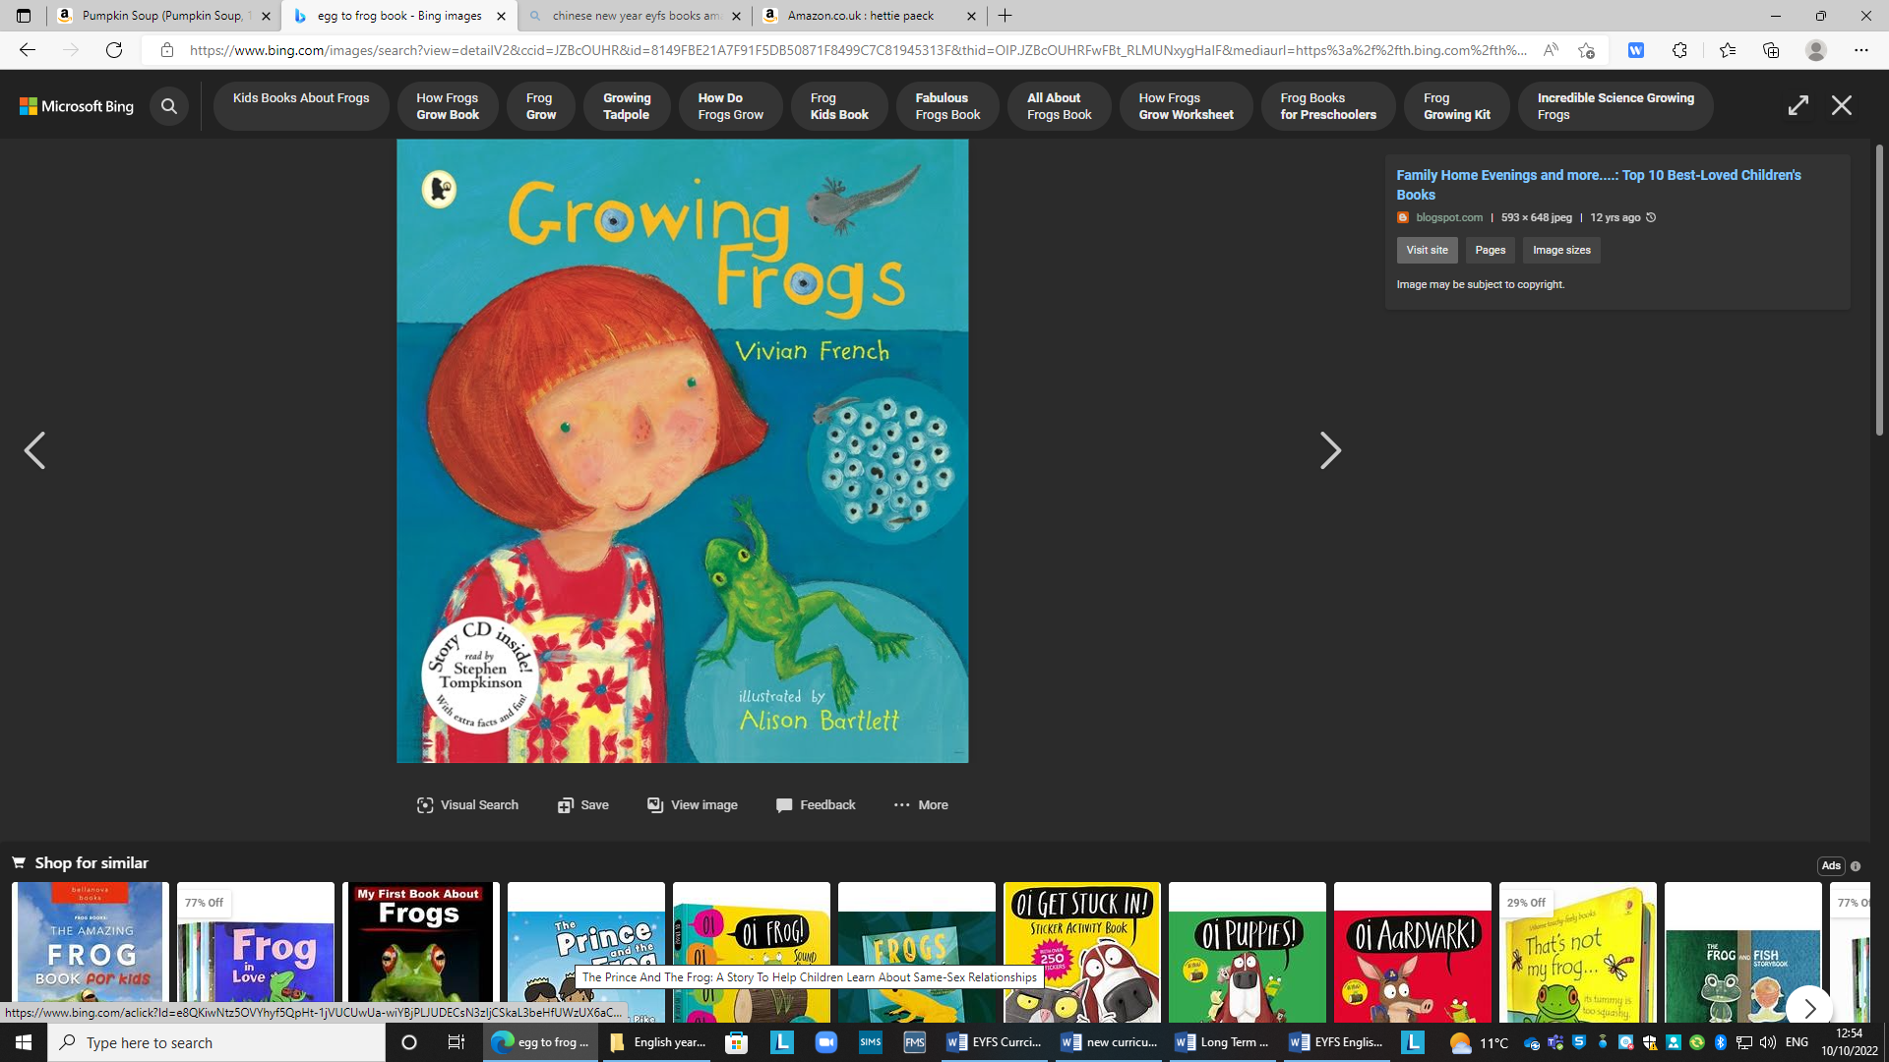 | What the Ladybird Heard, The very Hungry Caterpillar, Norman (the slug with a silly shell), The Bad-Tempered Ladybird, The Very Lazy Ladybird, The Very Busy Spider, Superworm, Very Greedy Bee, Rumple stilts kin  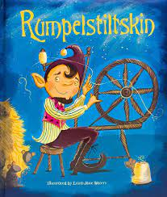 | What the Ladybird Heard at the Seaside, Hello Summer, Sharing a Shell, Puffin Peter, William Bee’s Wonderful World of Things That Go (non-fiction) Little People. Big dreams (Ernest Shackleton, Amelia Erkhart) You Choose Your Adventure, the little mermaid?  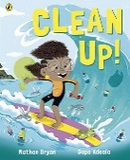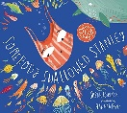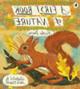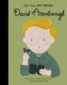  David Attenborough  Recycling project  Materials-sorting  Litter pick in local area
Linked Theme Rhyme | Dingle Dangle Scarecrow, Incy-Wincy Spider, Old Macdonald had a Farm, Cauliflowers fluffy and cabbages green, Head, shoulders, Knees and Toes, If you’re happy & you know it Autumn leaves are falling down, Oats and Beans and Barley Grow, The Hedgehog song (Mr Mottram’s songs) | Fireworks Go, Its Diwali, Happy Birthday, Bonfire Night, Remember the 5^{th of} November, 5 Little Penguins, 12 days of Christmas, Twinkle Twinkle Little Star, Little Jack Horner, Dridal Spin Spin, Chinese New Year (bigeyedowel.co.uk) Hanukkah (bigeyedowel.co.uk) Here we go round the Christmas tree, | Mix a Pancake, Sing a Song of Sixpence, 5 Little Pancakes, Hong Ching-Ting (bigeyedowel.co.uk) | Rain, Rain Go Away, Little Peter Rabbit, Sleeping Bunnies, 5 Currant Buns, Mary, Mary Quite Contrary | There’s a Worm at the Bottom of the Garden, There’s a Tiny Caterpillar, There’s a Tiny Caterpillar on a Leaf, Insects All Around, The Ants Go Marching In, five little bees, | Big Ship Sails, Bobby Shafto, A Sailer Went to Sea Sea, Theres a Whole in the Bottom of the Sea, We’re All Going on a Summer Holiday, Sally go Round the Sun, Row Row Row your Boat,
Theme Vocabulary | Celebrate, birthday, card, present, cake, candle, blow, wish, years old. Autumn, Harvest, pumpkin, farm, cabbage, cauliflower, oats, beans. | Hindu, festival, rangoli, Jesus, birth, celebration, faith, festive, winter, seasons, frost, ice, icicle remembrance, soldiers, war, Guy Fawkes, gunpowder, firework/fire – safety, explosion, sound, loud, crackle, screech, bang, heat, illuminate, night, evening | Winter, Chinese New Year, pancake, batter, flour, milk, China, frying pan, wok, noodles, lantern, wishing tree. | Eid, Celebration, family, prayers, spring, new life, Jesus, cross, spring, bloom | wings, habitats, life cycles, ladybird, caterpillar, cocoon, butterfly, frogspawn, tadpole, froglet, spider, web, bee, hive, honey, nectar, pollen. | Summer, seaside, holiday, adventures, sea, shells, sandcastle, waves, sunshine, travelling
Linked Literacy Texts | Goldilocks and the Three Bears, Farm Animal Books Who’s on the Farm,  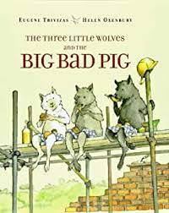 | Recipe books, recipe cards, shopping lists, menus, The Runaway Chapatti | The Queen’s Knickers, The Royal Nappy, The king’s Runaway Crown, Martha Maps it Out, Little people big world – King Charles Geography KS1: Transport, travel and landmarks of London - BBC Teach  Visit London with KeeKee: London Eye | Educational Video for Kids - Bing video  Big Ben for Kids: Famous World Landmarks for Children - FreeSchool - Bing video | The Enormous Turnip, Oliver’s Fruit Salad, The Tiny Seed, I Can Eat a Rainbow, The Extraordinary Gardener, We Eat Bananas, When Cucumber Lost His Cool, Where Does My Food Come From? Eating the Alphabet | Usbourne Beginners – ants, ladybird e.t.c, The Very Hungry Caterpillar Bug Hunt, Do You Love Bugs, Mad About Minibeasts How the Snail Found its Colours, | Billy ‘s Bucket, Octopus Shocktopus, The Rainbow Fish, Seaside Holidays then and Now, Look What I Found at the Seaside, Lucy & Tom at the Seaside, At the Beach (Roland Harvey)
Linked Literacy Rhyme | Old Macdonald had a Farm There was an old woman who lived in a shoe by Jane Cobrera | Pat-a-cake, Muffin man, on top of spaghetti by rock and learn rhymes | London Bridge is falling, The Grand Old Duke of York, London’s Burning. British Grenidere  The British Grenadiers  Some talk of Alexander  and some of Hercules  Of Hector and Lysander  and such great names as these  But of all the world's great heroes  there's none that can compare.  With a tow, row, row, row, row, row  to the British Grenadiers. | One Potato Two Potato, 5 Little Peas in a Pea Pod Press | Incey Wincey Spider  I’m a little lady bug (tune of I’m a little tea pot)  Little Arrabella Miller  One Little Bug  The ants go marching…  Five little bees  Little Miss Muffet | Commotion in the Ocean, Sharing a Shell, I Do Like to be Beside the Seaside,
Literacy Vocab | Straw, twigs, bricks, house, build, wolf, huff puff, blow, chimney, chin, roof, bad, trick, frightened. | feast, chopped, pounded, scooped, poured, sizzled, sprinkled bubbling, bumping, luminous | London, Queen, Big Ben, butler, Queens men, maids, Palace, corgi, sailed, whoosh, floated | garden, vegetable patch, leaves, crinkly, delicious, scrubbed, peel, chop, cut, pick | artist, trail, pattern, shy, portrait, pure, tough, melting, Matisse, gallery, spiral, frame, collage. | Limpet, exploring, squelching, tugged, heaved, groaned, chemicals, potions, pinchers, wiggled
Unit & Skills  Narrative | Text:  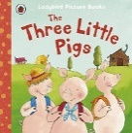  Oral Outcome: re-tell original/ innovation of the wolf  Written Outcome: Speech bubble | Text:  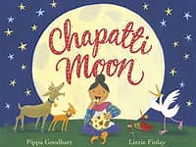  Oral Outcome: internalise abridged first 2 pages food and actions  Written Outcome: Lists of foods, ingredients and actions e.g. chop, cut, mix, pat, roll (Small group activity)…, invitations, thank you cards (adult modelling then provision based activities/challenges) | Text:  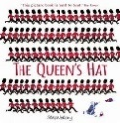  Hook –A servant runs in with a phone on a pillow…she is panicked, she tells the teacher that the Queen is upset and has lost her hat. She leaves and then the Queen calls the teacher and they discuss the lost hat.  Hat Hunt • Discuss what hats they own/know the names of. • Go on a hat treasure hunt to see how many hats they can find. This can link to the mathematical vocabulary of position and description of the hat e.g. The fluffy red hat with the bobble on was found under the chair.  Oral Outcome: re-telling of abridged version through sentence story map.  Written Outcome: simple repetitive sentences (The men …, The hat went…)  Innovated story oral/ written. | Text:  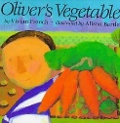  Oral Outcome: re-telling of abridged version through sentence story map including adjectives e.g. crunchy carrot  Written outcome:  Innovation (Oliver has found some fruit!) of what Oliver dug for abridged version including adjectives ‘He dug…. He found….. He picked…… He pulled…..’ | Text:    Oral Outcome: Discussions relating to Matisse’s feelings and alternative ways to communicate. Step into role as Matisse to verbalise his thoughts and feelings.  Written outcome:  Incidental writing - Different ways of communicating explore through the text – letters, cards, notes, messages, emails, think, say, feel bubbles.  Final outcome – each child writes a letter inviting their parents to their art show. | 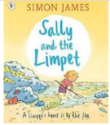  Text:  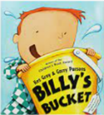  Hook: Story time Billy’s Bucket – developing imagination  and introducing seaside theme and vocab  Oral Outcome: role play character responses and more open-ended re-tell in their own words. Use ‘story mountain’ to scaffold structure of story – utilse pictures and speech bubbles/  Written outcome:  Simple innovated story changing the people who helped.
Unit & Skills  Non-fiction | 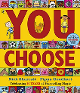  Text:  Homes  Big books  You choose texts - homes page.  Oral and or Writing outcome  Labelling, signs, environmental print  Labelling a house, | Text: Delicious Chapattis recipe card  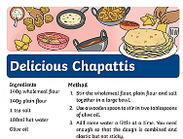  Hook – School cook has a problem  chapatti tasting  Oral and or Writing outcome  Instructions – lead to making edible sparklers (breadsticks, chocolate and sprinkles) – outdoor classroom  and sequencing pictures | 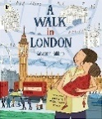  Text:  Hook – Maps an tour guides.  Oral Outcome: Tour guide for sights of London using videos of the sights and speaking over – record for other children visiting London  Written outcome:  Maps, labels and captions – detailed drawings of the sights of London | Text:  Healthy eating (see linked texts to generate background knowledge)  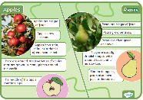  Oral Outcome:  Begin with exploration of environmental print e.g. street signs, shop signs, logos leading to discussions around posters and persuasion. Orally rehearse sentences following structure of food and what it is good at.  Written outcome:  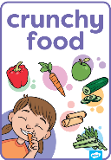  Innovate and improve a healthy eating poster about the fruit/veg they have explored e.g. Apples keep teeth strong. | 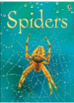  Text:  Usborne  Beginners  Spiders  Hook – create a giant spider’s web in the classroom  Oral Outcome: Act out being the spider, weaving the web and catching its prey. Technical vocab, sequencing  Written outcome:  Incidental writing Labelled drawing of a spider at the start of the unit then a labelled diagram at the end (refer to pg.3) , captions, vocab work  Final outcome create a fact file / booklet using diagrams, labels, simple sentences applying the technical vocab. (what it looks like? Where it lives? What it eats? Interesting facts | Text:  Recount non-fiction (big book)  Oral Outcome:  Oral recount (supported by pictures/photographs) of recent experience to introduce key vocab e.g. First (See Early Literacy Support)  Written outcome:  A written recount of a trip to Manchester Airport sequencing images from the day as a recount map before writing.
Non-Fiction Vocab | Components of a house  Wall, chimney, window, roof tile, detached, back to back, bungalow, cottage, terraced, flat, apartment, caravan, house boat, barge, shed, garage, garden, path, drive. | Ingredients, Chapati, Instructions, Flour, yeast, rise, flatten, round, circular, bake, fry, rolling pin, mix, change | King, Queen, Royalty, Succession, prince, princess, throne, crown, coronation, guard, soldier, bridge, palace | Crunchy, sweet, hard, soft, chewy, healthy, unhealthy, balanced, diet, vegetables, choices, vegetables, | Web, strength, silk, attach, spin, create, abdomen, excoskeleton, beginner, expert, information, | Visit, exhibit, trip, journey, destination, schedule, sea life, habitat, environment, coral, wildlife, species,
Unit & Skills  Poetry  (stand-alone poetry unit or integrated within above units) | 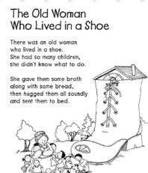  Text:  Hook – Shoe and old woman small world to start the whole theme  Oral and or writing  Watch different interactive versions to complement (the nice version!) Enjoy and begin to join in using words and actions.  https://www.youtube.com/watch?v=6L60sNSVClY | Text: 'I am the Baker Man' (tune ‘I am the Music Man’) BBC Teach  https://www.bbc.co.uk/teach/school-radio/nursery-rhymes-i-am-the-baker-man/zkjrf4j  Oral and or Writing outcome: Innovate the foods e.g. samosas, chapattis  Use a shared poetry map to help internalise and innovate orally with pictures | Text:  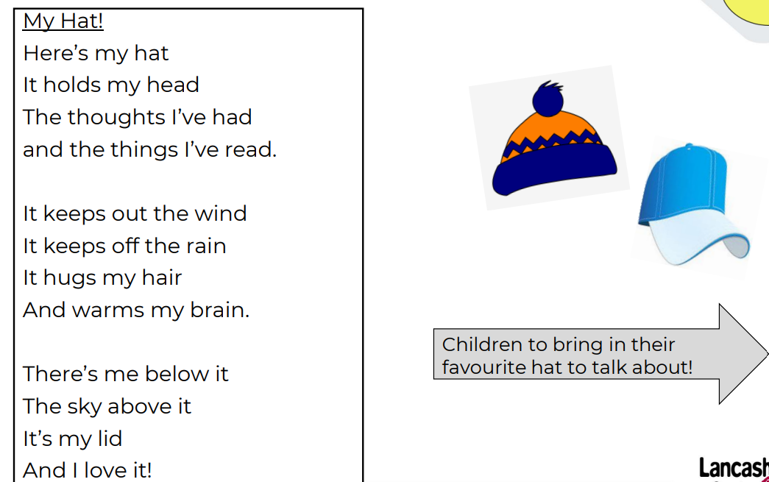  Sing a song of Sixpence  Oral and or Writing outcome: Learn the rhyme off by heart using interactive whiteboard versions, actions and props - innovate orally what comes out of the pie | 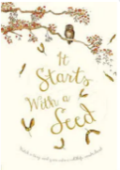  Text: It Starts  With a Seed  Growing - Explore text when planting veg e.g. runner beans/cress heads (quick growth veg)  Enliven the poem through action, dance, movement and music (PE)  Oral and or Writing outcome:  Perform poem/dance to an audience e.g. parents | 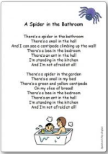  Text: A  Spider in  the bathroom  10 legs, 8 broken.  Enjoy original version - A spider in the bathroom  Explore rhyming pairs /strings (hall & wall, bed & bread) and extend – concertina legs on a spider  Oral and Writing outcome:  Use images to create a poetry map and learn abridged version with all sentences starting ‘There is a …. in the …’.  Innovate with knowledge of minibeasts explored | 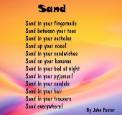  Text: Sand by John Foster  Oral and Writing outcome:  Learn the original using actions and focussing on the rhythm within the poem for performance.  Innovate the poem using a poetry map leading into an independent written innovation of the poem.
Links to other A of L promoting CLL  (see thematic overview) | Workshop area – cereal box homes to make a street display  Home corner – ‘sold’ house, boxes, children set up | Malleable – dough , rice, spaghetti, lentils flour and cutting, rolling equipment  Home corner with a focus on kitchen including multicultural play foods | Hook – robes and crowns arrive – each day two children (1 King, 1 Queen) Children chosen to agree on a rule each day. i.e. we only eat with knives and forks.  Queen’s hat appears  Portraits of kings and queens (Royal Portrait Gallery) Revisit and discuss the difference between painted portraits and photography, draw the king on the coin  Construction outdoors – landmarks , castles large scale  Maths – pairs, money  Bread & honey  Roles in the castle e.g. maid  Home corner – old fashioned home (home long ago)  PSED – rules – King and Queen of the day | Hook - School cook brings vegetable soup to try.  Visit Supermarket (vegetable department)  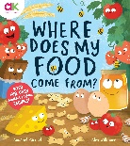  Recipes included in this book to try at home – parental links.  Explore potatoes (Oliver’s Vegetables) in UTW/Scientific Enquiry  ‘Logo’ Bingo Board – home learning find as many as they can e.g. Morrisons | Matisse – Artist inspirational people and create artwork  (secret messages, secret writing,  Create Matise inspired artwork using inspired media,  Explore minibeasts using easi-scope, collect snails for snail house, wormery, grow caterpillars and/or stick insects | 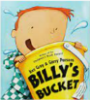  Billy’s Bucket  Design own bucket, generate ideas, magic glasses  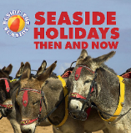  Seaside Holidays Then & Now  Patterns in nature e.g. rocks, shells, waves, sand  create rock pools  Caring for our environment & beach safety & pollution
Linked Theme Rhyme | Dingle Dangle Scarecrow, Incy-Wincy Spider, Old Macdonald had a Farm, Cauliflowers fluffy and cabbages green, Head, shoulders, Knees and Toes, If you’re happy & you know it Autumn leaves are falling down, Oats and Beans and Barley Grow, The Hedgehog song (Mr Mottram’s songs) | Fireworks Go, Its Diwali, Happy Birthday, Bonfire Night, Remember the 5^{th of} November, 5 Little Penguins, 12 days of Christmas, Twinkle Twinkle Little Star, Little Jack Horner, Dridal Spin Spin, Chinese New Year (bigeyedowel.co.uk) Hanukkah (bigeyedowel.co.uk) Here we go round the Christmas tree, | Mix a Pancake, Sing a Song of Sixpence, 5 Little Pancakes, Hong Ching-Ting (bigeyedowel.co.uk) | Rain, Rain Go Away, Little Peter Rabbit, Sleeping Bunnies, 5 Currant Buns, Mary, Mary Quite Contrary | There’s a Worm at the Bottom of the Garden, There’s a Tiny Caterpillar, There’s a Tiny Caterpillar on a Leaf, Insects All Around, The Ants Go Marching In, five little bees, | Big Ship Sails, Bobby Shafto, A Sailer Went to Sea Sea, Theres a Whole in the Bottom of the Sea, We’re All Going on a Summer Holiday, Sally go Round the Sun, Row Row Row your Boat,
Theme Vocabulary | Celebrate, birthday, card, present, cake, candle, blow, wish, years old. Autumn, Harvest, pumpkin, farm, cabbage, cauliflower, oats, beans. | Hindu, festival, rangoli, Jesus, birth, celebration, faith, festive, winter, seasons, frost, ice, icicle remembrance, soldiers, war, Guy Fawkes, gunpowder, firework/fire – safety, explosion, sound, loud, crackle, screech, bang, heat, illuminate, night, evening | Winter, Chinese New Year, pancake, batter, flour, milk, China, frying pan, wok, noodles, lantern, wishing tree. | Eid, Celebration, family, prayers, spring, new life, Jesus, cross, spring, bloom | wings, habitats, life cycles, ladybird, caterpillar, cocoon, butterfly, frogspawn, tadpole, froglet, spider, web, bee, hive, honey, nectar, pollen. | Summer, seaside, holiday, adventures, sea, shells, sandcastle, waves, sunshine, travelling
All aspects of developing CLL is considered throughout daily classroom practice, continuous provision, group time and weekly focus learning all have a weighty focus on CLL. Observations next steps and target setting support the development of individuals. Intervention programmes such as NELI-and differentiated group times are designed to support children who are not making the expected progress.
Prime Areas of Development
Physical Development (PD)
Gross Motor | Primary P.E Passport  Fundamental Movement Skills – Elmer  Basic skills• Experiments with different ways of moving.  -Revise and refine the fundamental movement skills they have already acquired: - rolling - crawling - walking - jumping (for distance) - running - hopping - skipping – climbing – travelling on hands and or feet, balancing on small or large body parts.  -Further develop and refine a range of ball skills including: throwing (under and over arm) and catching,  Use their core muscle strength to achieve a good posture when sitting at a table or sitting on the floor.  Continuous provision stations to reflect P.E lessons and embed skills. | Primary P.E Passport  Fundamental Movement Skills – How to Catch a Star  Basic skills• Experiments with different ways of moving.  Revise and refine the fundamental movement skills they have already acquired: - rolling - crawling - walking – jumping off (and landing) - running - hopping - skipping – climbing on large apparatus – travelling on hands and or feet, balancing on small or large body parts.  Use their core muscle strength to achieve a good posture when sitting at a table or sitting on the floor.  Continuous provision stations to reflect P.E lessons and embed skills. | Primary P.E Passport  Fundamental Movement Skills – Rosie’s Walk  Revise and refine the fundamental movement skills they have already acquired: - rolling – shuffling - sliding- crawling - walking – jumping off and landing appropriately - running - hopping - skipping – climbing on large apparatus – travelling on hands and or feet, balancing on small or large body parts – animal walks – bunny hop, caterpillar, crab walk, bear walk, frog jump.  Develop overall body-strength, balance, co-ordination and agility. Balancing on one leg.  -Confidently and safely use a range of large and small apparatus indoors and outside, alone and in a group.  Continuous provision stations to reflect P.E lessons and embed skills. | Primary P.E Passport  Fundamental Movement Skills – The Hungry Caterpillar  -Progress towards a more fluent style of moving, with developing control and grace  Revise and refine the fundamental movement skills they have already acquired: - rolling (rock and roll) – shuffling - sliding- crawling - walking – jumping off and landing appropriately - running - hopping - skipping – climbing on large apparatus – travelling on hands and or feet, balancing on small or large body parts –  Travelling low to the ground, over, under and through.  Develop overall body-strength, balance, co-ordination and agility. Balancing on a range of body parts. E.g. foot, bottom, back, tummy side, knees etc. Balancing competitions.  -Further develop and refine a range of ball skills including throwing (under and over arm) and catching.  -Develop the overall body strength, co-ordination, balance and agility needed to engage successfully with future physical education sessions and other physical disciplines including dance, gymnastics, sport and swimming.  Continuous provision stations to reflect P.E lessons and embed skills. | Primary P.E Passport  Fundamental Movement Skills – Super worm  Revise and refine the fundamental movement skills they have already acquired: - rolling - crawling - walking – jumping for distance – running (fast) – travelling on hands and feet) - hopping – skipping (with a rope) – climbing  -Further develop and refine a range of ball skills including: throwing (over arm) and catching.  - Develop confidence, competence, precision and accuracy when engaging in activities that involve a ball.  Develop overall body-strength, balance, co-ordination and agility. Balancing over and through balancing and climbing equipment.  To pull themselves up onto climbing equipment.  Continuous provision stations to reflect P.E lessons and embed skills. | Primary P.E Passport  Fundamental Movement Skills – Rumble in the Jungle  Consolidation unit.  Underarm throw, running fast, jumping for distance, rock and roll, travel on hands and feet, rolling a ball, one leg balance and balancing on small and large body parts.  Continuous provision stations to reflect P.E lessons and embed skills.  ELG 6. Gross Motor Skills ELG  Children at the expected level of development will:  Negotiate space and obstacles safely, with consideration for themselves and others.  Demonstrate strength, balance and coordination when playing.  Move energetically, such as running, jumping, dancing, hopping, skipping and climbing.
Fine Motor | -Develop their small motor skills so that they can use a range of tools competently, safely and confidently. Suggested tools: pencils for drawing and writing | -Develop their small motor skills so that they can use a range of tools competently, safely and confidently. Suggested tools: pencils for drawing and writing. | -Develop their small motor skills so that they can use a range of tools competently, safely and confidently. Suggested tools: pencils for drawing and writing.  ELG emerging Fine Motor- Hold a pencil effectively in preparation for fluent writing – using the tripod grip in almost all cases. | . -Develop their small motor skills so that they can use a range of tools competently, safely and confidently. Suggested tools: pencils for drawing and writing, paintbrushes, scissors, knives, forks and spoons.  - Develop the foundations of a handwriting style which is fast, accurate and efficient.  ELG 6. Gross Motor Skills ELG  Children at the expected level of development will: Negotiate space and obstacles safely, with consideration for themselves and others; Demonstrate strength, balance and coordination when playing; Move energetically, such as running, jumping, dancing, hopping, skipping and climbing.  ELG 7. Fine Motor Skills ELG  Children at the expected level of development will: Hold a pencil effectively in preparation for fluent writing – using the tripod grip in almost all cases; Use a range of small tools, including scissors, paint brushes and cutlery; Begin to show accuracy and care when drawing. | -Develop their small motor skills so that they can use a range of tools competently, safely and confidently. Suggested tools: pencils for drawing and writing, paintbrushes, scissors, knives, forks and spoons.  - Develop the foundations of a handwriting style which is fast, accurate and efficient.  ELG 6. Gross Motor Skills ELG  Children at the expected level of development will: Negotiate space and obstacles safely, with consideration for themselves and others; Demonstrate strength, balance and coordination when playing; Move energetically, such as running, jumping, dancing, hopping, skipping and climbing.  ELG 7. Fine Motor Skills ELG  Children at the expected level of development will: Hold a pencil effectively in preparation for fluent writing – using the tripod grip in almost all cases; Use a range of small tools, including scissors, paint brushes and cutlery; Begin to show accuracy and care when drawing | ELG 7. Fine Motor Skills ELG  Children at the expected level of development will:  Hold a pencil effectively in preparation for fluent writing – using the tripod grip in almost all cases.  Use a range of small tools, including scissors, paint brushes and cutlery.  Begin to show accuracy and care when drawing.
Ongoing throughout the year
- Know and talk about the different factors that support - their overall health and wellbeing:- regular physical activity- healthy eating- toothbrushing- sensible amounts of‘screen time’- having a good sleep routine - being a safe pedestrian
-Further develop the skills they need to manage the school day successfully: - lining up and queuing – mealtimes - personal hygiene.

Prime Areas of Development
Personal, Social, Emotional Development (PSED) Check with MC
Personal, Social and Emotional Development (PSED) | PSED is not specifically planned for across the year, however PSED Principles underpin daily classroom practice which ensures all aspects of developing PSED are covered. Observations and next steps are central to supporting children in making relationships, developing self-confidence and having an awareness and managing feelings and behaviour.
 | Emotional Health and Well Being.  School Rules: routines and boundaries  Forming positive relationships | Being Different  Anti-Bullying Week  Friendships  Playing together and taking turns.  Know where to find resources and equipment. | Economic Well Being Good to be Me  Working within a group  Being proud of their achievements  Talk about their ideas | Keeping Safe  Know how to keep safe  Share ideas and listen to others  Understand consequences of behaviour | Show care and concern for living things  Sequence ideas together  Understand consequences of behaviour | Relationships  Health  Resolve conflict without an adult.  Adapt to changes in routine/ transition.
Self-Regulation | - They will develop rules for their classroom and learn to share. | - They will begin to develop their understanding of what it means to make a choice and how some choices are better than others. | - Children will be continuing to develop friendships and learn to help others.  - Children will learn about our school values this half term of loyalty and teamwork. | -See themselves as a valuable individual.  --Identify and moderate their own feelings socially and emotionally.  - The children will be given more responsibility within the classroom and outside areas. | •Children will be further developing their understanding of what it means to make a choice and how some choices are better than others.  •They will be also be developing ‘staying power’ alongside concentration and determination.  •They will be given more opportunities to express and talk about their feelings. | ELG 3  3. Self-Regulation ELG  Children at the expected level of development will:  Show an understanding of their own feelings and those of others, and begin to regulate their behaviour accordingly;  Set and work towards simple goals, being able to wait for what they want and control their immediate impulses when appropriate;  Give focused attention to what the teacher says, responding appropriately even when engaged in activity, and show an ability to follow instructions involving several ideas or actions.
Managing Self | - Children will be settling into school, getting to know the staff, the environment and daily routines.  - Children will learn about our school values this half term of respect and responsibility. They will be encouraged to use good manners and take responsibility for jobs around the class. | - Children will be developing friendships, learning to be more co-operative and begin to reflect on how their actions affect others. | - They will begin to understand what a choice is and how to make choices.  - They will develop an understanding of values and reflect on how their actions can affect others. | -Manage their own needs.  -Express their feelings and consider the feelings of others  - Show resilience and perseverance in the face of challenge.  - They will develop their sense of right and wrong resulting in development of simple morals.  - Using their core text, Goldilocks, children will discuss her actions and talk about how her actions affected the three bears.  - Children will learn about our school values this half term of honesty and forgiveness. | •They will have chances to talk about and develop their own sense of self-worth | ELG 4  4. Managing Self ELG  Children at the expected level of development will:  Be confident to try new activities and show independence, resilience and perseverance in the face of challenge;  Explain the reasons for rules, know right from wrong and try to behave accordingly;  Manage their own basic hygiene and personal needs, including dressing, going to the toilet and understanding the importance of healthy food choices.
Building Relationships | - They will begin to form friendships and learn to play alongside other children.  - Children will build a relationship with their key worker.  - They will develop the skills needed to separate from parent/carer with support.  - They will take part in simple celebrations and start to learn about different religions and the special people and artefacts that are associated with them.  - End Points: The children will settle into the routines of school life and build relationships with their key worker and peers. | •They will take part in simple celebrations.  •They will talk about different religious and family celebrations.  •They will be finding out about other cultures/ religions and celebrations.  Children will learn about our school values this half term of kindness and diversity. They will talk about respecting each other’s differences and carrying out acts of kindness.  End Points: Children will learn about different ways people celebrate and will show respect for different religions and cultures. | - They will take part in celebrations and develop their knowledge of different religions e.g Chinese New Year  - Children will learn about friendships based on the Penguin books – using the characters to emphasise the need for friendships and respectful relationships.  - They will look at similarities and differences between different cultures.  - End Points: Children will learn about different ways people celebrate and will show respect for different religions and cultures. They will be able to talk about some similarities and differences between cultures and compare them to their own experiences. | -Build constructive and respectful relationships.  -Think about the perspectives of others.  - They will talk about family customs and their own experiences with celebrations.  - They will take part in simple celebrations and develop their knowledge of different religions and festivals e.g Easter.  End Points: Children will understand how their actions can affect others and make good choices based on this. | They will learn about the importance of caring for living things e.g growing plants. They will think about their responsibility in our school environment to care for living things.  They will take part in simple celebrations and start to learn about different religions and the special people and artefacts that are associated with them e.g Eid.  •Children will learn about our school values this half term of effort and determination.  End Points: Children will understand how to care for things in the environment, such as plants and animals. They will show care for things in our school gardens. | ELG 5  5. Building Relationships ELG  Children at the expected level of development will:  Work and play cooperatively and take turns with others;  Form positive attachments to adults and friendships with peers;  Show sensitivity to their own and to others’ needs.
British | Respects/ Diversity/ Rule of Law  Respect - We value respect by showing good behaviour and polite manners. Diversity - We value diversity by respecting everyone’s differences.  School rules  Class rules  School Values  Behaviour in school  Positive play | Mutual Respect Kindness and Diversity  Responsibility - We value our responsibility within our community.  Kindness - We value kindness as it helps to build friendships.  Fair play  Diwali  Remembrance Day  Christmas Story  Assemblies | Effort and Honesty  Effort - We value effort as it shows our determination to succeed.  Honesty - We value honesty by always telling the truth and taking responsibility for our actions.  Chinese New Year  Pancake day | Loyalty and Forgiveness  Loyalty - We value loyalty because it means we can trust and depend on each other.  Forgiveness - We value forgiveness as it shows strength of character. | Determination and Teamwork  Determination - We value determination so we can tackle difficulties in school and in life.  Team work - We value team work as together we learn. | Courage  Courage - We value courage as taking risks helps us to become confident people.  Moving to a new class – transition.
PSHE/ RSE links – Michelle is this correct?  Health and well being  Living in the Wider World  Relationships | All about me  Me and my Family  Who are my friends?  What foods do I like?  Welcome Assembly  Harvest  RSE focus - Mental well-being  Physical health and fitness | How do I keep safe?  Anti-Bullying/Friendship Week  Road Safety  RSE focus - Mental well-being  Families and people who care for me | Understanding and Respecting other cultures – Chinese New Year  ‘I have a Dream..’ Day  RSE focus - Being Safe  Mental well-being  Health and prevention/ Online Safety | Easter  Shrove Tuesday  Mother’s Day  RSE focus - Being Safe/ Health and Prevention | Sports Day – team work  Planting seeds/ bulbs  Life cycles/ nurture and caring  RSE Focus - Caring Friendships/ | Whole School Summer Project/ Performance  RSE Focus - Caring Friendships/ Mental Well-being

Specific Areas of Development
Literacy – Checking with MC
Phonics  (Red Rose Letters and Sounds) | Phase 2  s a t p i n m d g o c k  (s pronounced as Z)  Tricky  the | Phase 2  ck e u r h b f ff l ll ss  Tricky  I to go no into | Phase 3  j v w x y z zz  qu ch sh  th/th ng  Tricky  he she we me be was my you they | Phase 3  ai ee igh oa oo/oo ar or  Tricky  her all are like said when have one | Phase 3  Ur ow oi ear air ure er  Tricky  come do so were some there out little what | Phase 4  ccvc/ccvcc  Tricky  It’s
Comprehension | Comprehension  Introduce and read books to build up their confidence in word reading, their fluency and their understanding and enjoyment.  . | Comprehension  -Re-read books to build up their confidence in word reading, their fluency and their understanding and enjoyment. | Comprehension  -Re-read books to build up their confidence in word reading, their fluency and their understanding and enjoyment.  Introduce guided reading sessions in order to develop children’s comprehension. | Comprehension  Re-read books to build up their confidence in word reading, their fluency and their understanding and enjoyment. Children to be able to re-tell at least 1-2 familiar texts. | Comprehension  Re-read books to build up their confidence in word reading, their fluency and their understanding and enjoyment. Children to be able to re-tell at least 3 familiar texts. | Consolidating what has been taught to ensure children have the confidence and stamina to write at length.  Children begin to include detail in what they write and can read what they have recorded unaided. Children to be able to re-tell at least 3-5 familiar texts.  8. Comprehension ELG  Children at the expected level of development will:  Demonstrate understanding of what has been read to them by retelling stories and narratives using their own words and recently introduced vocabulary;  Anticipate – where appropriate – key events in stories;  Use and understand recently introduced vocabulary during discussions about stories, non-fiction, rhymes and poems and during role-play.
Word Reading | Reading  Recognise some initial letters  Read some simple VC and CVC words.  Hears and says the initial sound in words.  Can segment the sounds in simple words and blend them together and knows which letters represent some of them.  Retell favourite stories using some story language  Send home reading books and key word Humpty books. Identify daily target readers for lowest 20%. | Reading  Recognise and read key HFW.  Read some simple VC and CVC words and sentences.  Hears and says the sounds in words using phoneme frames. Continue with home-readers and daily target readers  Introduce guided reading.  Applying phonic knowledge to reading.  Can segment the sounds in simple words and blend them together and knows which letters represent some of them.  Send home reading books and key word Humpty books. Identify daily target readers for lowest 20%.  Blend sounds into words, so that they can read short words made up of known letter–sound correspondences.  Use and apply phonic knowledge when reading to recognise and read key HFW. | Reading  -Read individual letters by saying the sounds for them.  -Blend sounds into words, so that they can read short words made up of known letter–sound correspondences.  -Read some letter groups that each represent one sound and say sounds for them.  (Help children to become familiar with letter groups,  such as ‘th’, ‘sh’, ‘ch’, ‘ee’ ‘or’ ‘igh’)  -Read a few common exception words matched to the school’s phonic programme.  Read simple phrases and sentences made up of words  with known letter–sound correspondences and, where  necessary, a few exception words.  - -Re-read what they have written to check that it makes sense.  Continue to recognise and read key HFW.  Read CVC sentences.  Use phoneme frames to write words and sentences with phase 2/3 sounds in them.  Use phonic knowledge to retell a story in simple sentences.  Continue with home-readers, daily target readers and guided reading.  Use and apply phonic knowledge when reading to recognise and read key HFW.  When writing use Phase 2/3 letters and sounds to support what is being written. Retell favourite stories using story language and time connectives e.g “First, Next, Then, After that, Finally”  Continue with home-readers and daily target readers  Continue guided reading. | Reading  Continue to recognise and read key HFW.  Read CVC/ CVCC sentences.  Use phoneme frames to write words and sentences with phase 3 sounds in them.  Use phonic knowledge to retell a story in simple sentences.  Continue with home-readers, daily target readers and guided reading.  Use and apply phonic knowledge when reading to recognise and read key HFW.  Continue with home-readers and daily target readers  Continue guided reading. | Reading  Continue to recognise and read key HFW.  Read CVC/ CVCC sentences.  Use phoneme frames to write words and sentences with phase 3/4 sounds in them.  Introduce Phase 5 for HA children.  Use phonic knowledge to retell a story using complex sentences – Jack and the Beanstalk.  Continue with home-readers, daily target readers and guided reading.  Use and apply phonic knowledge when reading to recognise and read key HFW. | 9. Word Reading ELG  Children at the expected level of development will:  Say a sound for each letter in the alphabet and at least 10 digraphs;  Read words consistent with their phonic knowledge by sound-blending;  Read aloud simple sentences and books that are consistent with their phonic knowledge, including some common exception words.
Writing | Writing - Write own name  Write some initial sounds  Write simple words. | Writing - Write own name  Write some initial sounds  Write simple words.  Begin to record simple captions and labels using dominant sounds. | Writing - Write own name  Write some initial sounds  Write simple sentences using VC and CVC words.  Record simple captions and labels using phase 2/3 sounds. Begin to write for a purpose, sequencing ideas together and recognising key features that need to be included such as finger spaces – instructional writing/ letter writing/ diary entries etc. | Writing - When writing use Phase 3 letters and sounds to support what is being written. Retell favourite stories using story language and time connectives e.g “First, Next, Then, After that, Finally” – | Writing- When writing use Phase 3/4 letters and sounds to support what is being written. Retell favourite stories using story language and time connectives e.g “First, Next, Then, After that, Finally” – Jack and the Beanstalk  When writing use Phase 3 letters and sounds to support what is being written. Retell favourite stories using story language and time connectives e.g “First, Next, Then, After that, Finally” – | 10. Writing ELG  Children at the expected level of development will:  Write recognisable letters, most of which are correctly formed;  Spell words by identifying sounds in them and representing the sounds with a letter or letters;  Write simple phrases and sentences that can be read by others
Specific Areas of Development
Mathematical Development (MD) Set to change with New Red Rose Pilot
Throughout the year the skills taught will include:
Number focus: 0-10 and beyond, recognition/counting/ordering/one to one correspondence/recording numbers, number bonds to 10, counting in 10’s and 2’s, addition/subtraction, doubling & halving, sharing, recognising money and its uses, solving simple number problems, guided reasoning.
Numerical Patterns
Numerical Patterns – Shape, Space and Measure focus: 2D/3D Shapes & Properties, capacity knowing how much something can hold, finding out how tall/short/wide something is, measuring and weighing amounts for a purpose, data to find out and record information, sorting information to a given criterion, sequencing different times of the day, making patterns, sequencing, positional language.
Maths Skills | Counting  · Take part in finger rhymes with numbers (birth to 3)  Counting-like behaviour, such as making sounds, pointing or saying some numbers in sequence (birth to 3)  · Understand that counting is to find out how many (birth to 3)  · Say one number for each item in order: 1, 2, 3, 4, 5 (3 & 4 year olds)  · Know the last number reached when counting a small set of objects tells you how many there are in total (‘cardinal principle’) (3 & 4 year olds)  · Count in everyday contexts, sometimes skipping numbers – ‘1-2-3-5’ (birth to 3)  Count in everyday contexts, sometimes skipping numbers – ‘1-2- Statistics  Sort objects and say what features they have in common (3 & 4 year olds)3-5’ (birth to 3) | Space - pattern  · Talk about and identifies the patterns around them. For example, stripes on clothes, designs on rugs and wallpaper.  Use informal language like ‘pointy’, ‘spotty’, blobs’ etc. (3 & 4 year olds) ·  Extend and create ABAB patterns – stick, leaf, stick, leaf (3 & 4 year olds) · Notice and correct an error in a repeating pattern (3 & 4 year olds)  Counting  · Take part in finger rhymes with numbers (birth to 3)  Say one number for each item in order: 1, 2, 3, 4, 5 (3 & 4 year olds)  · Show ‘finger numbers’ up to 5 (3 & 4 year olds)  · Use the word ‘zero’ to represent ‘none’ (3 & 4 year olds)  Compare amounts, saying ‘lots’, ‘more’ or ‘same’ (birth to 3)  Compare quantities using language: ‘more than’, ‘fewer than’ (3 & 4 year olds)  Number – number recognition  Recognise and identify numerals 0 to 5 (3 & 4 year olds)  · Link numerals and amounts: for example, showing the right number of objects to match the numeral, up to 5 (3 & 4 year olds)  Shape  Combine objects like stacking blocks and cups (birth to 3)  · Talk about and explore 2D and 3D shapes (for example, circles, rectangles, triangles and cuboids) using informal mathematical language: ‘sides’, ‘corners’; ‘straight’, ‘flat’, ‘round’ (3 & 4 year olds) | Counting  Fast recognition of up to 3 objects, without having to count them individually (subitising) (3 & 4 year olds)  Understand and use conservation of number (3 & 4 year olds)  Calculating  React to changes of amount in a group of up to three items (birth to 3)  · Understand the concept of addition by practically combining sets of objects to find how many (3 & 4 year olds)  In real life contexts add two single-digit numbers totalling within 5, using practical equipment (3 & 4 year olds)  Number – number sense  Partition a set of objects in different ways (3 & 4 year olds)  · Know that numbers greater than 1 can be made in different ways (3 & 4 year olds)  Positional language shape  Put objects inside others and take them out again (birth to 3)  Understand position through words alone – for example, “The bag is under the table,” – with no pointing (3 & 4 year olds)  · Describe a familiar route (3 & 4 year olds)  · Discuss routes and locations, using words like ‘in front of’ and ‘behind’ (3 & 4 year olds) | Counting  Say one number for each item in order: 1, 2, 3, 4, 5 (3 & 4 year olds)  · Know the last number reached when counting a small set of objects tells you how many there are in total (‘cardinal principle’) (3 & 4 year olds)  Calculating  Understand the concept of subtraction by practically removing one amount from within another to find how many are left (3 & 4 year olds)  In real life contexts subtract a single-digit number from a number up to 5, using practical equipment (3 & 4 year olds)  In real life contexts find one more and one less than a given number (3 & 4 year olds)  Graphics  Experiment with their own symbols and marks as well as numerals (3 & 4 year olds)  · Represent and explain their thinking in their own ways (birth to 3)  Shape  Combine objects like stacking blocks and cups (birth to 3)  · Talk about and explore 2D and 3D shapes (for example, circles, rectangles, triangles and cuboids) using informal mathematical language: ‘sides’, ‘corners’; ‘straight’, ‘flat’, ‘round’ (3 & 4 year olds  Name common 2-D shapes (circle, triangle, square, rectangle, oblong)  Talk about shapes using mathematical language (straight, curved, sides, flat, solid | Number – number sense  Partition a set of objects in different ways (3 & 4 year olds)  · Know that numbers greater than 1 can be made in different ways (3 & 4 year olds)  Number – number recognition  Recognise and identify numerals 0 to 5 (3 & 4 year olds)  · Link numerals and amounts: for example, showing the right number of objects to match the numeral, up to 5 (3 & 4 year olds)  Counting  Understand and use conservation of number (3 & 4 year olds  Solve real world mathematical problems with numbers up to 5 (3 & 4 year olds)  Number graphics  Experiment with their own symbols and marks as well as numerals (3 & 4 year olds)  · Represent and explain their thinking in their own ways (birth to 3)  Weight  Use language of full and empty to describe the amount in different containers (birth to 3)  · Make comparisons between objects relating to capacity e.g. more/less (3 & 4 year olds) | Number graphics  Experiment with their own symbols and marks as well as numerals (3 & 4 year olds)  · Represent and explain their thinking in their own ways (birth to 3)  Number – number sense  Partition a set of objects in different ways (3 & 4 year olds)  · Know that numbers greater than 1 can be made in different ways (3 & 4 year olds)  Counting  Understand and use conservation of number (3 & 4 year olds  Solve real world mathematical problems with numbers up to 5 (3 & 4 year olds)  In real life contexts find one more and one less than a given number (3 & 4 year olds)
Specific Areas of Development
Understanding the World (UW)
Past and Present | History - ELG 13: Past and Present  Talk about the lives of the people around them.  Key Question/s  Who is special in my family?  Who lived in my family in the past?  Substantive Concepts - Childhood  Disciplinary Concepts –  Historical significance  Key Vocabulary  My family, me, I, my home, special, house,  Key topic Knowledge -  Make connections between their own family and other families.  Know who is in their family.  Know who lives with them in their house.  Know who is special to them.  Chronological knowledge  Know who is in their family in the present.  Know who was in their family in the past.  Past and Present - Seasonal changes – exploring Autumn time.  Eid  Class rules, boundaries and routines.  Other faiths and culture.  Understanding about what is happening in the world around them.  Talking about themselves, their home and their family.  Past and present experiences.  Accessing I-pads  Phonics games  Maths games  Using the IWB  Understanding how to work technological equipment. | History - ELG 13: Past and Present  Talk about the lives of the people around them.  Key Question/s  Who is special in my family?  Who lived in my family in the past?  Substantive Concepts - Childhood  Disciplinary Concepts -  Historical significance  Key Vocabulary  My family, me, I, my home, special, house,  Key topic Knowledge -  Make connections between their own family and other families.  Know who is in their family.  Know who lives with them in their house.  Know who is special to them.  Chronological knowledge  Know who is in their family in the present.  Know who was in their family in the past.  Past and Present  - Comment on images of familiar situations in the past.  - Compare and contrast characters from stories, including figures from the past.  Light and dark  Bonfire night – keeping safe  The Christmas Story  Birthdays  Weddings  Diwali  Eid  Light and dark  Expresso  Purple Mash – fireworks pictures | Past and Present  Compare and contrast characters from stories, including figures from the past.  Weather/Seasons  Hot and Cold Countries  Chinese New Year taste Chinese Food.  Penguins  Freezing & Melting  Ice  Waterproof materials – forest school:  Mother’s Day  Other cultures and different faiths. | History - ELG 13: Past and Present  Talk about the lives of the people around them and their roles in society.  Key Question/s  What is the role of the local police?  Substantive Concepts - Equality and justice  Disciplinary Concepts -  Historical significance  Key Vocabulary –  Local, police, help keep us safe, look after us,  Key topic Knowledge –  There are people whose job it is to help us.  The police help us to keep safe.  The police help us to follow rules.  Chronological knowledge  Talk about the key roles people have had in society both in the present and in the past.  Past and Present  Compare and contrast characters from stories, including figures from the past.  Park visit – mapping our route  Easter  Teachers link to Easter story - Christianity  Growing – planting seeds ready for the Summer term.  Maths games  Phonic games  Paint program | History - ELG 13: Past and Present  Know some similarities and differences between things in the past and now.  Key Question/s  How long have I lived here?  Substantive Concepts – Migration  Disciplinary Concepts -  Similarities and differences  Key Vocabulary –  Foulridge, moving house, country, family, me, I, my family, house, home.  Key topic Knowledge -  Know how long they have lived in their house.  Know how long their parents/ family have lived here.  Understand that people move house.  Understand that people can move from one place to another.  Know that there are differences and similarities between people and communities.  Know that there are different countries in the world and talk about the differences that they have experienced or seen in photos.  Make some connections between the features of their family and other families.  Chronological knowledge  Talk about the present and the past.  Understand that people can move house over time.  Understand that people don’t always live in the same place forever.  ELG 13. Past and Present ELG  Children at the expected level of development will:  Talk about the lives of the people around them and their roles in society;  Know some similarities and differences between things in the past and now, drawing on their experiences and what has been read in class;  Understand the past through settings, characters and events encountered in books read in class and storytelling;  Growing and planting  Caring for plants  Weather chart  Life cycles: bees, butterflies, frogs.  Growing  Programmable toys | History - ELG 13: Past and Present  Know some similarities and differences between things in the past and now.  Key Question/s  How long have I lived here?  Substantive Concepts – Migration  Disciplinary Concepts - Similarities and differences  Key Vocabulary  Foulridge, moving house, country, family, me, I, my family, house, home.  Key topic Knowledge -  Know how long they have lived in their house.  Know how long their parents/ family have lived here.  Understand that people move house.  Understand that people can move from one place to another.  Know that there are differences and similarities between people and communities.  Know that there are different countries in the world and talk about the differences that they have experienced or seen in photos.  Make some connections between the features of their family and other families.  Chronological knowledge  Talk about the present and the past.  Understand that people can move house over time.  Understand that people don’t always live in the same place forever.  ELG 13. Past and Present ELG  Children at the expected level of development will:  Talk about the lives of the people around them and their roles in society;  Know some similarities and differences between things in the past and now, drawing on their experiences and what has been read in class;  Understand the past through settings, characters and events encountered in books read in class and storytelling;  Growing and planting  Keeping Healthy  Changes in weather  Changes in the environment.  Similarities and differences.
 | Expectations for the Autumn Term  - Remember and talk about significant events in their own experience e.g. birthday  - Recognise and describe special times or events e.g. birthday, Christmas, christening  - Know and understand that grandparents are older than parents  - Become familiar with words and phrases such as ‘in the past’ or ‘a long time ago’ |  | Expectations for the Spring Term  - Begin to compare and contrast characters in stories set in the past  - Use appropriate language to describe the past such as ‘in the past’  - Begin to understand the some familiar stories were set in a time before they were born |  | Expectations for the Summer Term  - Talk about the lives of people around them and their roles in society  - Know some similarities and differences between things in the past and now, drawing on their experiences and what has been read in class  - Understand the past through settings, characters and events encountered in books read in class and storytelling
People and Communities | Geography  Local- my school  Where I live  Journey to school  Mapping- Teddy  Autumn walk- seasonal changes  Place and Locational Knowledge  Know the name of my school.  Know the town/city where I live.  Know basic relative positional language.  Know that England is their home country.  Know that London is the capital city of England.  Understand the terms ‘land’ and ‘sea’.  Make simple comparisons between their locality and other relevant places in the world (e.g. where their parents/families come from).  Make simple comparisons between familiar environments (e.g. home, school, farm).  People and Communities –  Talk about members of their immediate family and community.  Name and describe people who are familiar to them.  Class rules, boundaries and routines.  Other faiths and culture.  Understanding about what is happening in the world around them.  Talking about themselves, their home and their family.  Past and present experiences.  Accessing I-pads  Phonics games  Maths games  Using the IWB  Understanding how to work technological equipment. | Geography  People, Culture and Communities  Places special to members of the community  Visit to our local church.  Visit to our local cenotaph for remembrance.  Names of different countries where celebrations take place.  Physical geography  Name the four seasons and begin to describe associated weather.  Talk about the weather daily.  Begin to use basic geographical vocabulary to refer to key physical features of the local area and the UK, such as: beach, cliff, coast, forest, hill, mountain, hill, sea, ocean, river, soil, season and weather.  People and Communities  Understand that some places are special to members of their community  - Recognise that people have different beliefs and celebrate special times in different ways  - Draw information from a simple map.  Light and dark  Bonfire night – keeping safe  The Christmas Story  Birthdays  Weddings  Diwali  Eid  Light and dark  Expresso  Purple Mash – fireworks pictures | History - ELG 14: People, Culture and Communities  Know some similarities and differences between different religious and cultural communities in this country.  Key Question/s  What are the important places in Foulridge?  Substantive Concepts – Civilisations  Disciplinary Concepts - Similarities and differences  Key Vocabulary  Foulridge, church, school, building, road, village,  Key topic Knowledge -  There are differences between people and communities.  There are different countries in the world and talk about the differences that they have experienced or seen in photos.  Our school is located in Foulridge.  Our school is located on Skipton Road.  The church is located in Foulridge.  Chronological knowledge  Understand that places change over time.  Human Geography  Begin to use basic geographical vocabulary to refer to key human features of the local area and the UK, including town, city, country, capital, road, street, shops, etc.  Recognise the shops and enterprises in the locality, including being aware of their names.  People and Communities-  Recognise some similarities and differences between life in this country and life in other countries.  Weather/Seasons  Hot and Cold Countries  Chinese New Year taste Chinese Food.  Penguins  Freezing & Melting  Ice  Waterproof materials – forest school:  Mother’s Day  Other cultures and different faiths. | Geography - Geographical skills (including fieldwork)  Locate chosen country/countries of parental heritage on globes/maps.  To identify the land and sea on world globes/maps.  Begin to use simple locational/directional language (e.g. near, far, up, down, left, right, forwards and backwards) to describe the location of features on a local map and to move around the school.  Begin to use observational skills to draw simple plans and routes around their classroom, school, and local area.  Take photos of buildings and places in school.  People and Communities –  - Draw information from a simple map.  Park visit – mapping our route  Easter  Teachers link to Easter story - Christianity  Growing – planting seeds ready for the Summer term.  Maths games  Phonic games  Paint program | Developing ELG 14. People Culture and Communities ELG  Children at the expected level of development will:  Describe their immediate environment using knowledge from observation, discussion, stories, non-fiction texts and maps;  Know some similarities and differences between different religious and cultural communities in this country, drawing on their experiences and what has been read in class;  Explain some similarities and differences between life in this country and life in other countries, drawing on knowledge from stories, non-fiction texts and – when appropriate – maps.  Growing and planting  Caring for plants  Weather chart  Life cycles: bees, butterflies, frogs.  Growing  Programmable toys | ELG 14. People Culture and Communities ELG  Children at the expected level of development will:  Describe their immediate environment using knowledge from observation, discussion, stories, non-fiction texts and maps;  Know some similarities and differences between different religious and cultural communities in this country, drawing on their experiences and what has been read in class;  Explain some similarities and differences between life in this country and life in other countries, drawing on knowledge from stories, non-fiction texts and – when appropriate – maps.  Growing and planting  Keeping Healthy  Changes in weather  Changes in the environment.  Similarities and differences.
The Natural World | Science - Seasonal Changes  Explore the natural world around them. • Describe what they see, hear and feel whilst outside. • Understand the effect of changing seasons on the natural world around them.  Geographical Vocabulary - beach, cliff, coast, forest, hill, mountain, sea, ocean, river, soil, hill, season and weather, land, sea, Foulridge, village, England, home church,, house, family, school, farm, map, near, far, up, down. weather types (sun, rain, thunder, snow, wind), road, street
 | Science - Humans  Talk about members of their immediate family and community.  Name and describe people who are familiar to them.  Class rules, boundaries and routines.  Other faiths and culture.  Understanding about what is happening in the world around them.  Past and present experiences.  Accessing I-pads  Phonics games  Maths games  Using the IWB  Understanding how to work technological equipment. | Science - Materials including changing materials.  Explore the natural world around them.  (Observe and interact with natural processes, such as ice melting, a sound causing a vibration, light travelling through transparent material, an object casting a shadow, a magnet attracting an object and a boat floating on water.)  Geography - Physical Geography  Name the four seasons and begin to describe associated weather.  Talk about the weather daily.  Begin to use basic geographical vocabulary to refer to key physical features of the local area and the UK, such as: beach, cliff, coast, forest, hill, mountain, hill, sea, ocean, river, soil, season and weather.  Describe what they see, hear and feel whilst outside.  Light and dark  Bonfire night – keeping safe  The Christmas Story  Birthdays  Weddings  Diwali  Eid  Light and dark  Expresso  Purple Mash – fireworks pictures | Science - Forces  Explore the natural world around them.  Describe what they see, hear and feel whilst outside..  - Explore the natural world around them. (Observe and interact with natural processes, such as ice melting, a sound causing a vibration, light travelling through transparent material, an object casting a shadow, a magnet attracting an object and a boat floating on water.)  - Recognise some environments that are different to the one in which they live.  - Understand the effect of changing seasons on the  natural world around them.  Weather/Seasons  Hot and Cold Countries  Chinese New Year taste Chinese Food.  Penguins  Freezing & Melting  Ice  Waterproof materials – forest school:  Mother’s Day  Other cultures and different faiths. | Science - Earth and space  Explore the natural world around them.  Describe what they see, hear and feel whilst outside.  Light  Describe what they see, hear and feel whilst outside.  - Explore the natural world around them. (Observe and interact with natural processes, such as ice melting, a sound causing a vibration, light travelling through transparent material, an object casting a shadow, a magnet attracting an object and a boat floating on water.)  - Recognise some environments that are different to the one in which they live.  Park visit – mapping our route  Easter  Teachers link to Easter story - Christianity  Growing – planting seeds ready for the Summer term.  Maths games  Phonic games  Paint program | Science - Animals excluding humans  Recognise some environments that are different to the one in which they live.  Living things and their habitats  Draw information from a simple map.  Explore the natural world around them. Describe what they see, hear and feel whilst outside.  Recognise some environments that are different to the one in which they live.  Geography - Geographical enquiry  Ask questions about aspects of their familiar world.  Draw things they see around them.  Communicate simple geographical information with support, orally, using simple pictures, maps and through writing.  Describe their immediate environment and express their views about it, with support.  Developing ELG 15 The Natural World ELG  Children at the expected level of development will:  Explore the natural world around them, making observations and drawing pictures of animals and plants;  Know some similarities and differences between the natural world around them and contrasting environments, drawing on their experiences and what has been read in class;  Understand some important processes and changes in the natural world around them, including the seasons and changing states of matter.  Growing and planting  Caring for plants  Weather chart  Life cycles: bees, butterflies, frogs.  Growing  Programmable toys | Science – Sound  Describe what they see, hear and feel whilst outside.  Geography - Geographical enquiry  Ask questions about aspects of their familiar world.  Draw things they see around them.  Communicate simple geographical information with support, orally, using simple pictures, maps and through writing.  Describe their immediate environment and express their views about it, with support.  ELG 15 The Natural World ELG  Children at the expected level of development will:  Explore the natural world around them, making observations and drawing pictures of animals and plants;  Know some similarities and differences between the natural world around them and contrasting environments, drawing on their experiences and what has been read in class;  Understand some important processes and changes in the natural world around them, including the seasons and changing states of matter.  Growing and planting  Keeping Healthy  Changes in weather  Changes in the environment.  Similarities and differences.
Specific Areas of Development
Expressive Arts and Design (EAD)
Being Imaginative  Creating with Materials | Patterns in Art  Drawing  Artist: Freda Kahlo  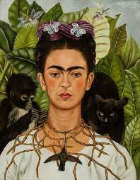  Creating with materials  -Create collaboratively, sharing ideas, resources and skills.  Drawing pictures of families/ themselves  Autumnal painting – colour mixing  Singing lots of songs and familiarising children with regular singing.  Sand and Water  Mud Kitchen | Painting  Artist: Megan Coyle    Being Imaginative – Music focus  Listen attentively, move to and talk about music, expressing their feelings and responses.  Explore, use and refine a variety of artistic effects to  express their ideas and feelings.  - Watch and talk about dance and performance art,  expressing their feelings and responses.  - Sing in a group or on their own, increasingly matching the pitch and following the melody  - Develop storylines in their pretend play.  - Explore and engage in music making and dance, performing solo or in groups  Bonfire night paints and textures.  Christmas cards  Calendars  Making stickman puppets.  Christmas craft, cards and decorations.  Firework sounds  Link celebrations topic to pieces of music - dance  Christmas songs  Using role-play to act out different scenes. | Seasonal Craft  Exploring cold colours  Artist: Turner Snowstorm  Threaded Snowflakes  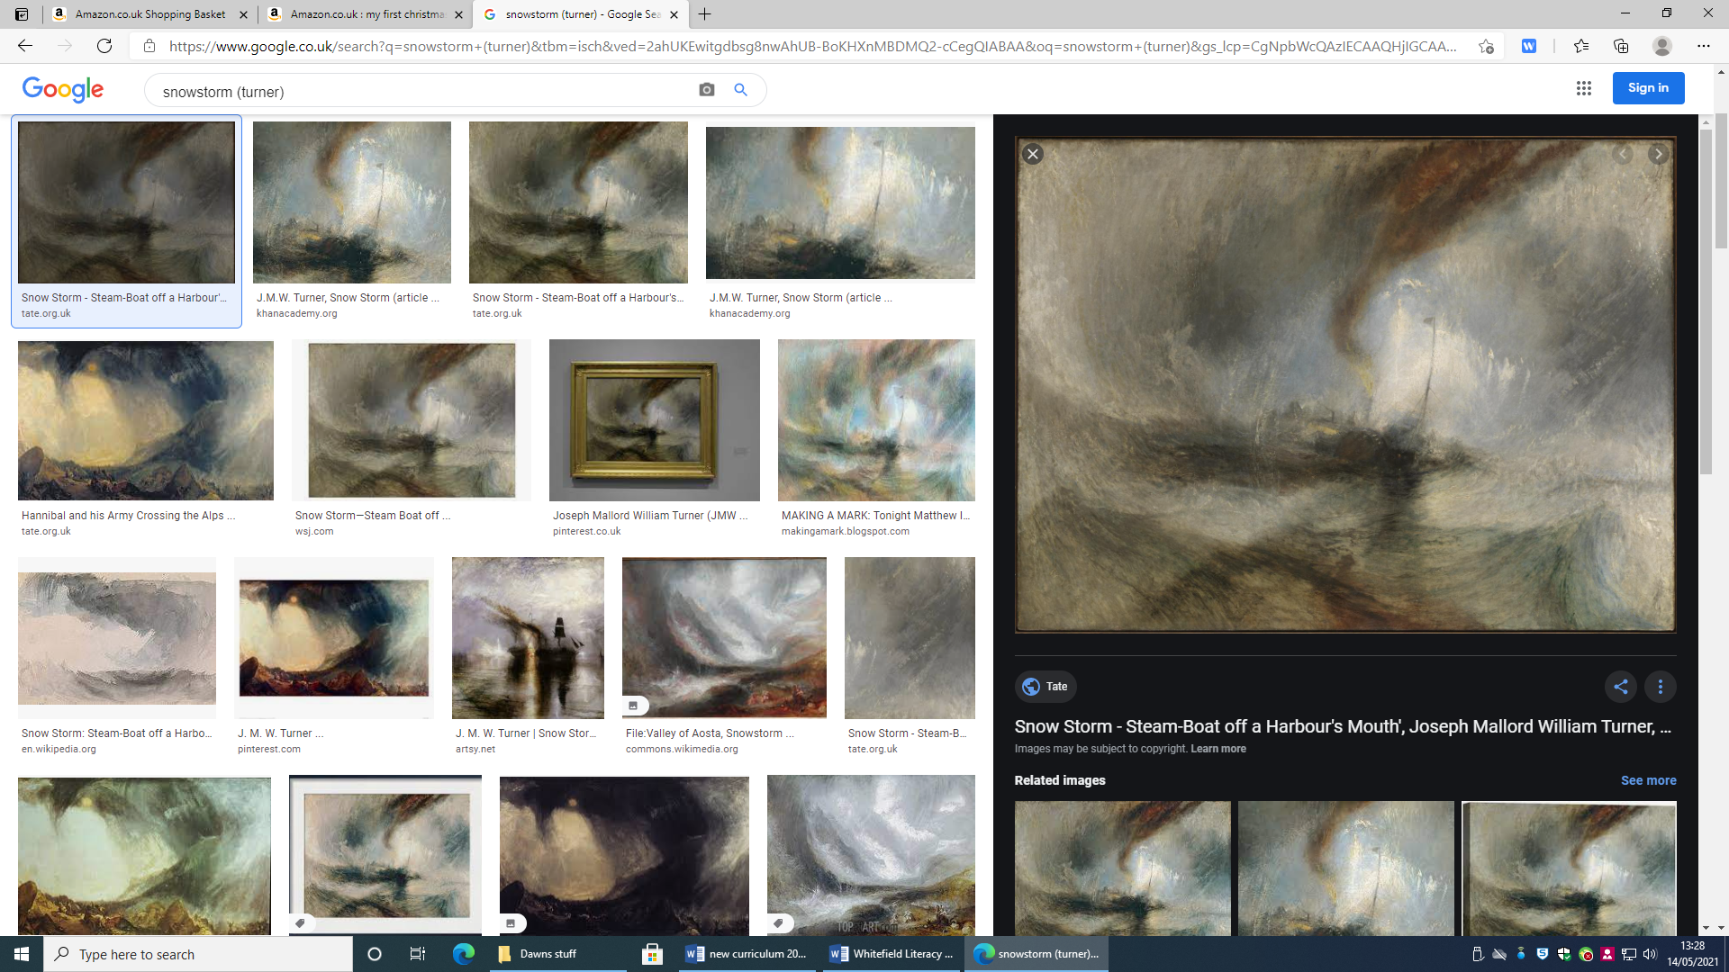  Being Imaginative explore hot and cold colours, use and refine a variety of artistic effects to  express their ideas and feelings.  - Sing in a group or on their own, increasingly matching the pitch and following the melody  - Develop storylines in their pretend play.  - Explore and engage in music making and dance, performing solo or in groups. (Play music with a pulse for children to move in time with and encourage them to respond to changes: they could jump when the music suddenly becomes louder, for example.)  Colour mixing cold colours / Winter art – using wax crayons and watercolours  Making characters from core  Winter collages  Malleable materials  Mother’s Day cards  Chinese role-play  Chinese dragon dance  Chinese dragon song  Chinese music and sounds | Mandelas Suncatchers  Andy Goldsworthy  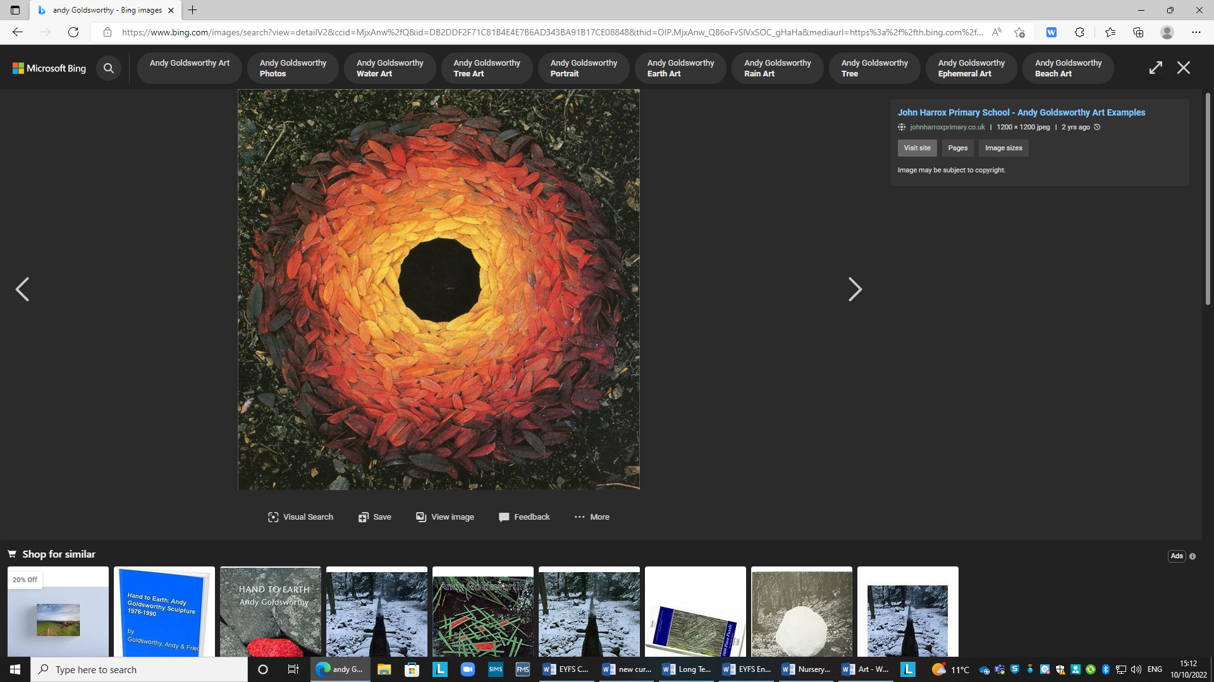  Creating with Materials  - Return to and build on their previous learning, refining  ideas and developing their ability to represent them. (Teach children different techniques for joining  materials, such as how to use adhesive tape and  different sorts of glue).  Easter craft  Sand and Water  Mud Kitchen  Lots of map work – drawing maps – retracing steps on journey  Share their creations, explaining the process they have used;  Make use of props and materials when role playing characters in narratives and stories. | 3D Designing Sculptures  Artists: Beth Cavener and Julie Wilson  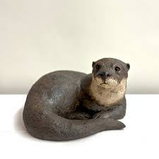  ELG 16. Creating with Materials ELG  Children at the expected level of development will:  Safely use and explore a variety of materials, tools and techniques, experimenting with colour, design, texture, form and function;  ELG 17. Being Imaginative and Expressive ELG  Children at the expected level of development will:  Invent, adapt and recount narratives and stories with peers and their teacher;  Sing a range of well-known nursery rhymes and songs;  Perform songs, rhymes, poems and stories with others, and – when appropriate – try to move in time with music.  Planting seeds and observational drawings/ painting of plants/ flowers | Craft  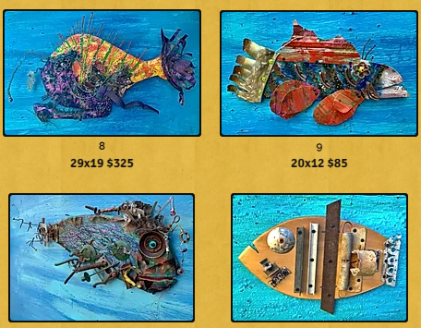  Artist: Rodney ‘Rodrigo’ McCoubrey  ELG 16. Creating with Materials ELG  Children at the expected level of development will:  Safely use and explore a variety of materials, tools and techniques, experimenting with colour, design, texture, form and function;  Share their creations, explaining the process they have used;  Make use of props and materials when role playing characters in narratives and stories.  ELG 17. Being Imaginative and Expressive ELG  Children at the expected level of development will:  Invent, adapt and recount narratives and stories with peers and their teacher;  Sing a range of well-known nursery rhymes and songs;  Perform songs, rhymes, poems and stories with others, and – when appropriate – try to move in time with music.
Music | Throughout the year children will be partake in the Charanga Music Scheme. These are the key skills children will learn.  Understanding Music - Watch and talk about dance and performance art, expressing their feelings and responses. Clap out beat structure of longer words.  Listen and Appraise - Understand how to listen carefully and why listening is important. Listen carefully to rhymes and songs, paying attention to how they sound. Listen attentively, move to and talk about music, expressing their feelings and responses.  Singing - Learn rhymes, poems and songs. Sing in a group or on their own, increasingly matching the pitch and following the melody.  Composing and Performing –Play instruments with increasing control to express their feelings and ideas. Explore collections of materials with similar and/or different properties. Create their own songs or improvise a song around one they know. Explore and engage in music making and dance, performing solo or in groups.  Explore and Create - Musical Activities that embed pulse, rhythm and pitch, explore voices and classroom instruments.
 | Me!  Main Songs  Pat-a-cake 1, 2, 3, 4, 5, Once I Caught a Fish Alive This Old Man Five Little Ducks Name Song Things For Fingers | My Stories  Main songs  I’m A Little Teapot The Grand Old Duke Of York Ring O’ Roses Hickory Dickory Dock Not Too Difficult The ABC Song | Everyone  Main Songs  Wind The Bobbin Up Rock-a-bye Baby Five Little Monkeys Jumping On The Bed Twinkle Twinkle If You're Happy And You Know It Head, Shoulders, Knees And Toes | Our World  Main Songs  Old Macdonald Incy Wincy Spider Baa Baa Black Sheep Row, Row, Row Your Boat The Wheels On The Bus The Hokey Cokey | Big Bear Funk  Main Songs  Big Bear Funk | Reflect, Rewind and Replay  Main Songs  Big Bear Funk Baa Baa Black Sheep Twinkle Twinkle Incy Wincy Spider Rock-a-bye Baby Row, Row, Row Your Boat
Extra Curricular Enrichment/ Cultural capital | - Extra Curricular Enrichment | - Learn to ride  - Visit to the church at Harvest  - Visit to the church at Advent/Christmas | - Pantomime  - Church visit - lent | - Tadpoles  - Butterflies  - Plant growth | - Local walk  - Visit from people who help us – police, fire etc  - Live egg  - Visit to the church at Easter  - Tadpoles  - Butterflies  - Plant growth | - Visit to the Sea Life Centre  - Tadpoles  - Butterflies  Plant growth
Parental engagement | - Transition visits  - Parents to send in photographs of their family | - Parents phonics workshop  - Invite parents to send in wedding photos for discussion  - Festival of Light assembly  - Learning and Reporting Meetings |  | - Phonics workshop  - Stay and play session | New Life Assembly | - Transition to year 1 workshop
Assessment | - Baseline assessments  - EY tracker  - Gap reports  - Floor book input  - Outdoor planning/evaluation floorbook | - Gap reports  - EY tracker  - Pupil progress  - Floor book input  - Outdoor planning/evaluation floorbook  - Moderation | - Review gap reports  - Floor book input  - Outdoor planning/evaluation floorbook  - Moderation | - Spring EY tracker  - Gap reports  - Pupil progress  - Floor book input  - Outdoor planning/evaluation floorbook  - Moderation | - EYFS Profile  - Review gap report  - Pupil progress  - Floor book input  - Outdoor planning/evaluation floorbook  - Moderation | - Summer EY tracker  - Gap reports  - Pupil progress  - Transition reports  - Year 1 teacher meeting

