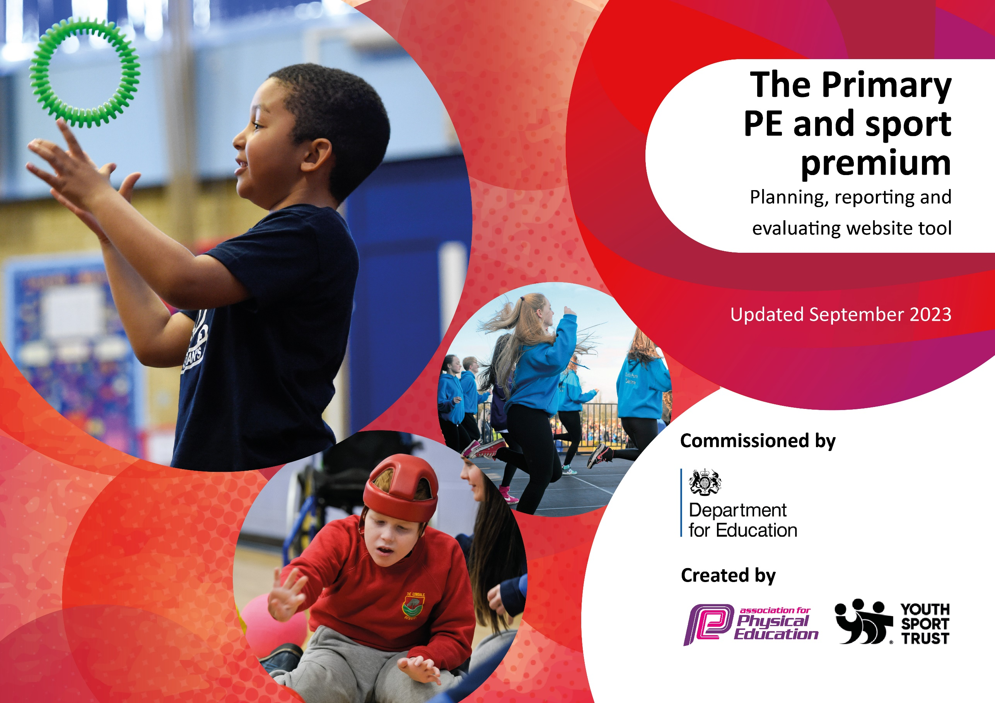

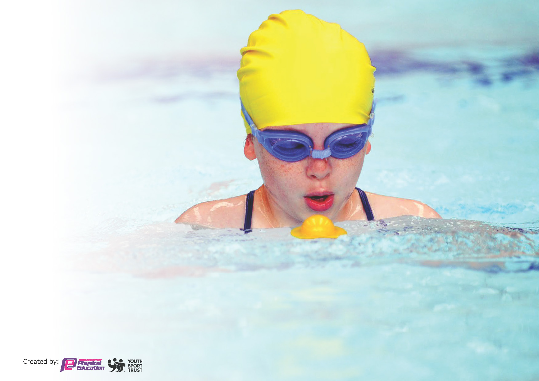
This template can be used for multiple purposes:
by:
- It enables schools to effectively plan their use of the Primary PE and sport premium
- It helps schools to meet the requirements (as set out in guidance) to publish information on their Primary PE and sport premium
- It will be an effective document to support Ofsted inspections enabling schools to evidence progress in Physical Education (PE) and evidence swimming attainment, which forms part of the PE National Curriculum. We would recommend schools consider
the Intent, Implementation and Impact of any spend, as examined within the Education Inspection Framework.

It is important that your grant is used effectively and based on school need.

Schools must use the funding to make additional and sustainable
improvements to the quality of the PE, School Sport and Physical Activity (PESSPA)
they offer. This means that you should use the Primary PE and sport premium to:

- Build capacity and capability within the school to ensure that improvements made now will benefit pupils joining the school in future years
- Develop or add to the PESSPA activities that your school already offers.

The Primary PE and sport premium should not be used to fund capital spend projects; the school’s core budget should fund these. Further detail on capital expenditure can be found in the updated Primary PE and sport premium guidance.

The Primary PE and sport premium guidance, outlines 5 key priorities that funding should be used towards. It is not

necessary that spending has to meet all the key priorities, you should select the priorities that you aim to use any funding towards.

Although completing this template is not a requirement for schools, schools are required to publish details of how they spend this funding. Schools must also outline what the impact this funding has had on pupils’ PE and sport participation and attainment and how any spending will be sustainable in the future. All funding must be spent by 31st July 2024.

The Department for Education has worked closely with the Association for Physical Education (afPE) and the Youth Sport Trust (YST) to develop this template and encourages schools to use it. This template is an effective way of meeting the reporting requirements of the Primary PE and sport premium.
Review of last year’s spend and key achievements (2022/2023)

We recommend you start by reflecting on the impact of current provision and reviewing your previous spend.

Activity/Action | Impact | Comments
Attended 37 Pendle School sports Partnership events last academic year.

Achieved School Games Gold award for fourth year running.

209 pupils between years 2 and 6 regularly attend 23 different types of healthy lifestyle/ sports clubs/activities outside of school. Survey conducted Autumn 1 2023

Key priorities and Planning
This planning template will allow schools to accurately plan their spending.

Action – what are you planning to do | Who does this action impact? | Key indicator to meet | Impacts and how sustainability will be achieved? | Cost linked to the action
Develop sporting opportunities during the school day at St. Michael’s;  KS2 trained playground leaders to develop their role by encouraging more active lifestyles through organised playtime /lunchtime games  (12 KS2 chdn. Trained Sept. 2023)  Continued development of running track class challenges for all children  Personal Best’ lunchtime challenge club to create interest/desire to improve performance/lifestyle  New & additional PE/Sport equipment (curriculum specific) to ensure opportunities for quality PE provision are provided  Half Termly designated PE/Sports Assembly to celebrate achievements in & out of school to raise awareness of PE/Sport & encourage all pupils to aspire to be involved  Role models celebrated so children identify with success & aspire to follow a similar path | Impacts all children. UKS2 play leaders delivering sports/games to EYFS/KS1 & KS2 pupils. (New equipment provided Sept.2023)  All pupils. New challenges on running track noticeboards & rewards in PE assemblies  Opportunities for all children to access healthy activity in a non-competitive/sporting environment  Quality PE provision is provided for all pupils  Achievements celebrated in assembly (match reports/names of participants/out of school sporting success shared with all)  ‘Sports For Champions’ Athlete visit/circuit training fundraiser event/presentation assembly for whole school (March 20th 2024) | Key indicator 1: The engagement of all pupils in regular activity ensuring each child does 30 mins per day.  Key indicator 2: The profile of PESSPA being raised across the school for whole school improvement | Continued training for School Sports Council members/Play Leaders to ensure quality of play/lunchtime games  Achieve personal bests/complete a targeted distance e.g. To New York or a 26 mile marathon. Weekly class best scores to earn a variety of awards: Certificates/wristbands/fitbits etc.  Weekly club with standout performances/awards in PE/Sports assemblies  Sustainable & long lasting learning resource. Sports council to assist setting new termly challenges  Raised self-esteem, children rewarded with trophies/medals/certificates etc.  ‘Sports For Champions’ Athlete visit/circuit training fundraiser event/presentation assembly for whole school (March 20th 2023) | £720  £300.00  £  £304.99  £100.00  £1,000.00  £100.00  £500.00

Ensure PE, physical activity & wellbeing are at the core of the school vision & values  Continual development of PE subject lead & staff to facilitate the best practice across school & attend relevant PE courses to ensure CPD for PE lead & staff . Attend termly PLT PE/Sports lead cluster meetings/courses to ensure CPD. Staff to observe RP annually for CPD.  Level 5 PE Specialism Qualification to be completed by OL  NEW: Inclusive PE (JM)  Subscribe to a range of sporting bodies to allow access to a range of opportunities & training for staff & children. Continue to subscribe to the Pendle Schools Sports Partnership enabling access to a wide range of sporting activities & training opportunities  Provide school sports kits for boys and girls to wear whilst representing school at events.  Develop the use of outdoor learning training/provision for staff/children & incorporate after school clubs e.g. orienteering club  Continual National Curriculum swimming provision for Y5 & Y4 classes  Top up swimming for Y6 who have not met curr standard. Take pupils during the summer term for top up lessons to enable children to meet the standard  Provide staffing, transport & resources enabling access to a wide range of sporting activities (more events now during the school day to enable targeted pupils to access healthy lifestyle activities)  Continue link with ‘Go  ‘Go Velo’ to provide bikeability for EYFS ‘Learn to Ride’ & Y5 & Y6. Potentially purchase Balance Bikes for EYFS. (Nov. 2022).  - Continue link with Judith Wood/Gillian Rowan Wilde (Pendle Orienteering Club) to lead half termly clubs. School to continue hosting Inter-schools orienteering events throughout the year.  Ensure all children have the opportunity to take part in participation/competitive events throughout the school year  Children identified & entered into a variety of SSP organised participation events specific to the needs of individuals  - Participate in 80%+ of PSSP events  - Engender school/team & individual pride in our school sports teams with kit provided for all attendees. | All inclusive traditional sports day that allow individual to showcase their skills and learn Core values of respect, resilience, self-belief & being active & healthy are being reinforced  Maintain, develop & improve quality of whole school PE provision. Improved behaviour & confidence in PE impacts positively in other curriculum areas  To provide specialized after school clubs for pupils from rec to year 6. Also provides expertise and advice for teachers.  All pupils have opportunity to represent St Michael and All Angels.  All children representing St Michael and All Angels at various points throughout the year wearing kits with pride.  All pupils and staff  Year 6 pupils who have not met curriculum standard.  All children in school | Key indicator 3: Increased confidence, knowledge and skills of all staff in teaching PE and sport  To complete September 2024  Key indicator 4: Broader experience of a range of sports and activities offered to all pupils  TBA  To take place during summer term 2024  Key Indicator 5: Increased participation in competitive sport | Repeat annually & celebrate in assemblies  PE lead to continue actions to ensure standard of PE provision, maintain subscription to Pendle Schools Sports Partnership.  Maintain, develop & improve quality of whole school PE provision. Improved behaviour & confidence in PE impacts positively in other curriculum areas  Develop confidence in delivering and assessing PE and Games units of work through the Lancashire PE APP  Sustained in house after school clubs without relying on outside agencies  Enter termly sports events as organised by SSP leader  Annual subscription.  Majority of KS2 children engaged in physical/sporting activity at least once per week  Develop social/life skills in an outdoor learning environment  Develop/maintain area(s) of school grounds to facilitate outdoor learning experiences  Majority of children able to swim confidently, competently & proficiently over 25 metres (Y5 assessment Feb. 2023 & Y4 July 2023)  Staff & children able to attend a variety of sporting events throughout the academic year & during school day – targeting those that cannot access after school  Target individuals who have not participated/are unable to attend after school sports events.  Children completing bikeability course, improving riding confidence/skills  Greater opportunity for individual competitive events/develop map skills/environmental awareness/health & fitness  A greater range of children participate in a non-competitive environment  Targeted individuals encouraged to participate/experience new sporting opportunities | £200.00  £255.00  £995.00  £3,720.00  £209.00  £1,822.00  £1,200.00  £148.00  £300.00  £1,116.50  £2,537.50  £625.00  £250.00  £  £800.00

Key achievements 2023-2024
This template will be completed at the end of the academic year and will showcase the key achievements schools have made with their Primary PE and sport premium spending.

Activity/Action | Impact | Comments

Swimming Data
Meeting National Curriculum requirements for swimming and water safety.
Priority should always be given to ensuring that pupils can perform safe self-rescue even if they do not fully meet the first two requirements of the National Curriculum programme of study

Question | Stats: | Further context  Relative to local challenges
What percentage of your current Year 6 cohort can swim competently, confidently and proficiently over a distance of at least 25 metres? | 44% | Use this text box to give further context behind the percentage.  e.g., 30% - we are struggling to get pool space due to our local pool closing so we have had to use a much smaller local school pool. We have had to limit the number of pupils attending swimming lessons during one term which means some pupils have attended fewer swimming lessons than others.
What percentage of your current Year 6 cohort can use a range of strokes effectively [for example, front crawl, backstroke, and breaststroke]? | 44% | Use this text box to give further context behind the percentage.  e.g., Even though your pupils may swim in another year please report on their attainment on leaving primary school at the end of the summer term 2024

What percentage of your current Year 6 cohort are able to perform safe self-rescue in different water-based situations? | 84% | Use this text box to give further context behind the percentage.
If your schools swimming data is below national expectation, you can choose to use the Primary PE and sport premium to provide additional top-up sessions for those pupils that did not meet National Curriculum  requirements after the completion of core lessons. Have you done this? | Yes | Summer term 2024
Have you provided CPD to improve the knowledge and confidence of staff to be able to teach swimming and water safety? | Yes | PE lead to attend training at PLT meeting

Signed off by:

Head Teacher: | (Name)
Subject Leader or the individual responsible for the Primary PE and sport premium: | (Name and Job Title)
Governor: | (Name and Role)
Date:

