St. Michael and All Angels CE VA School
Concrete, Pictorial and Abstract Calculation Policy

September 2023

At St Michael and All Angels we teach mathematics through delivering a mastery approach. We use and adapt the Lancashire Red Rose Mastery planning.

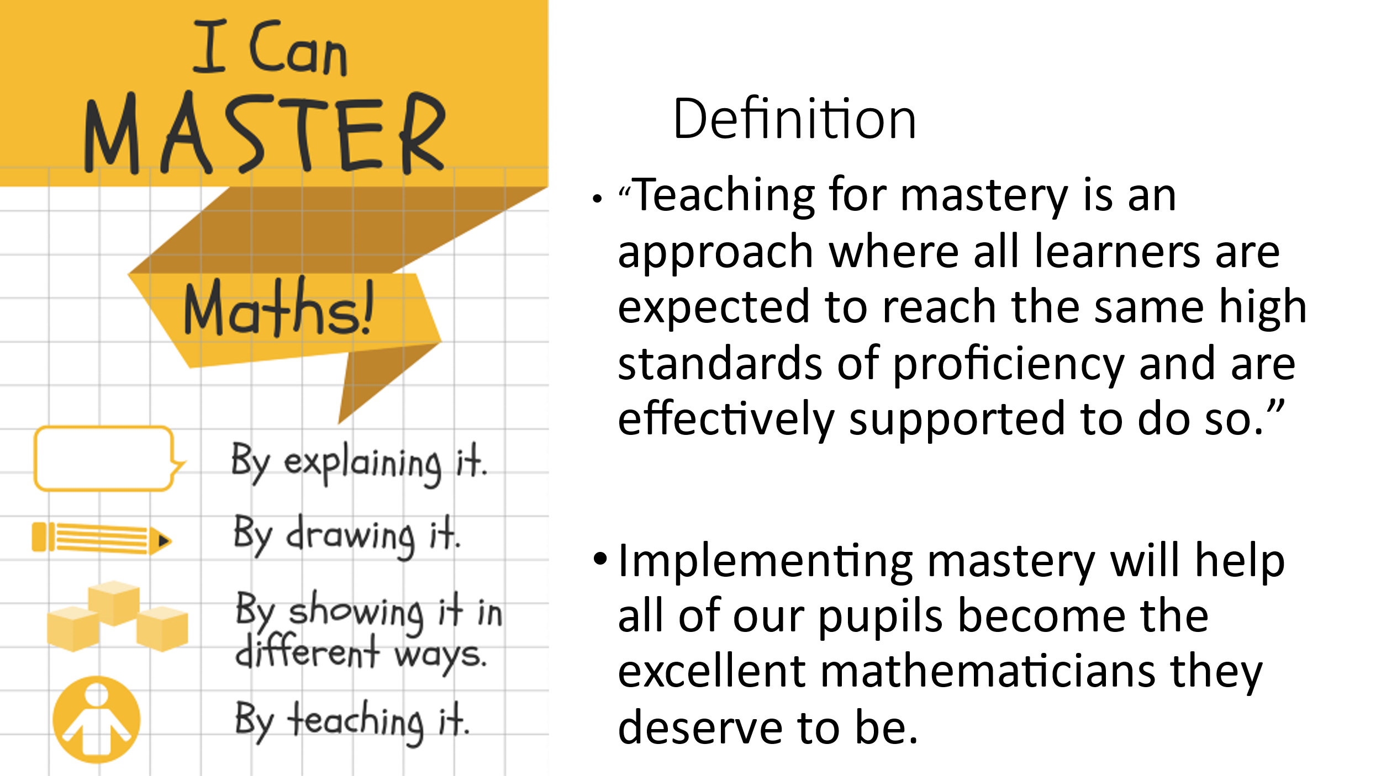

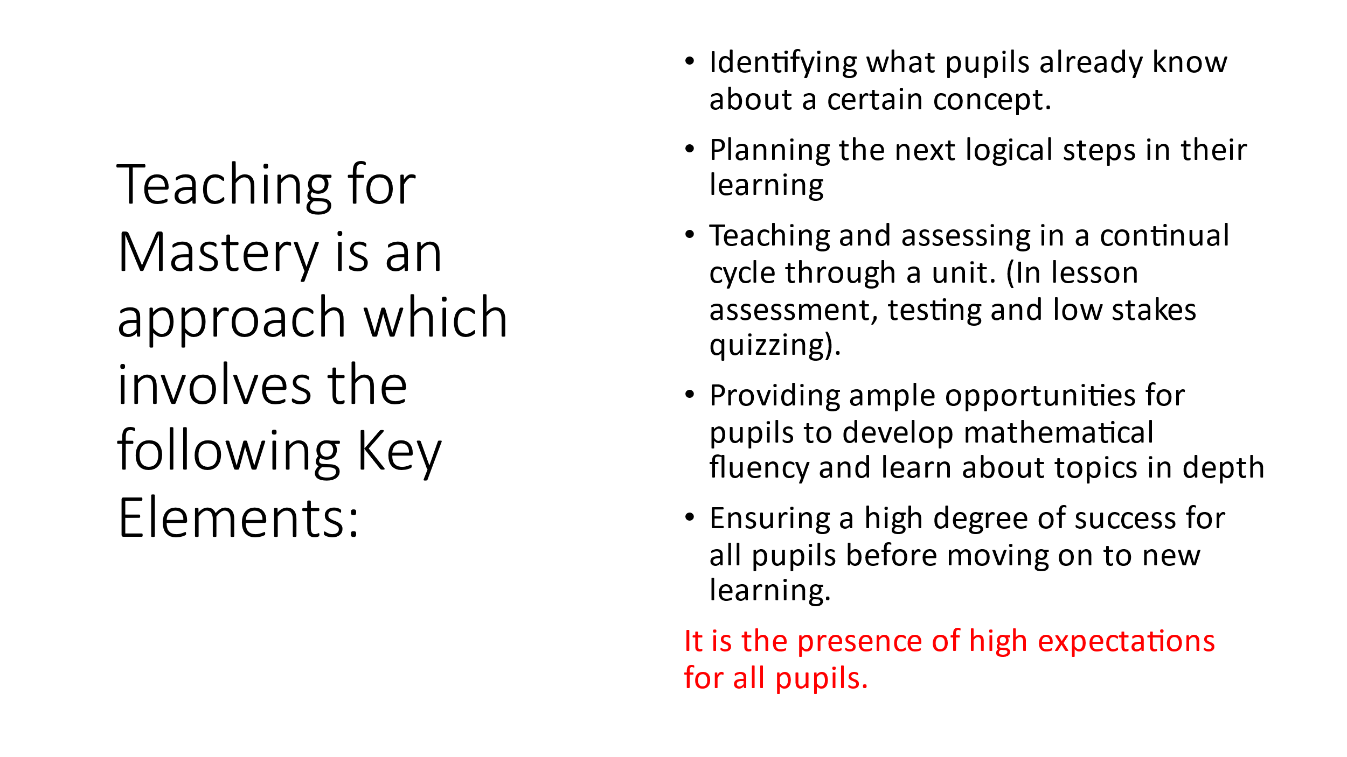
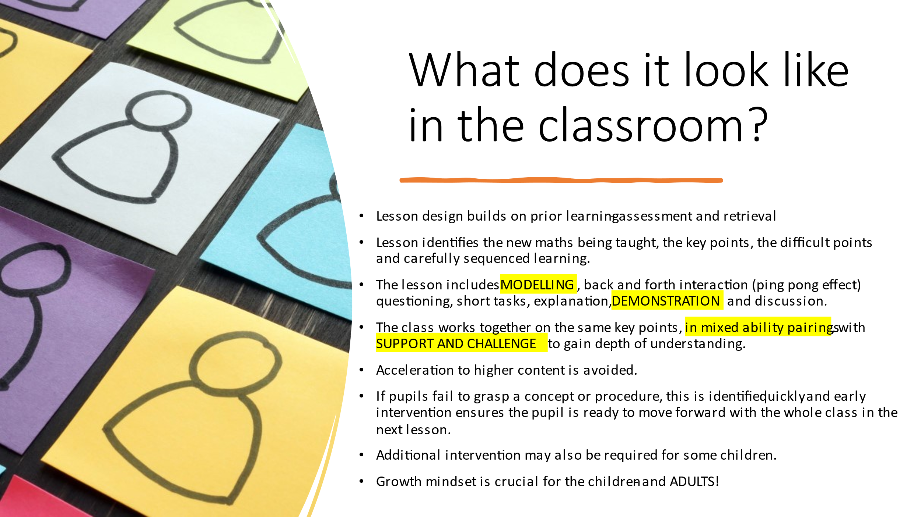

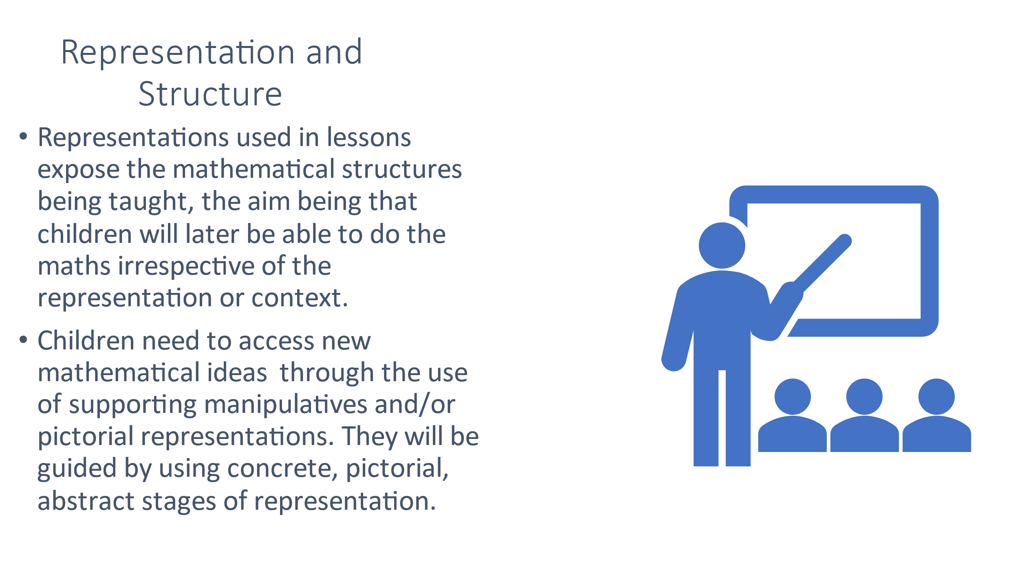

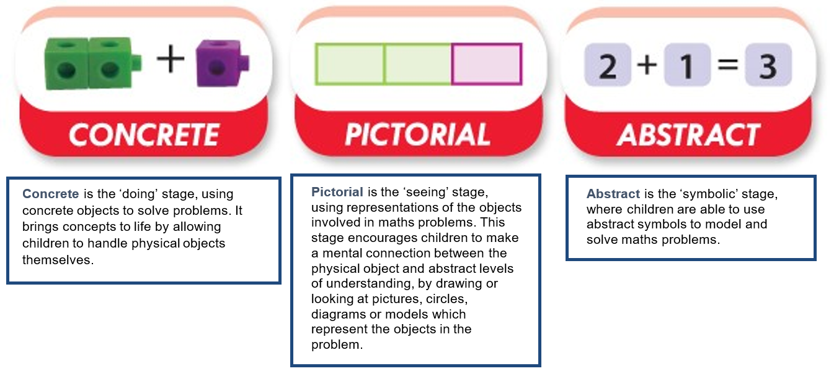

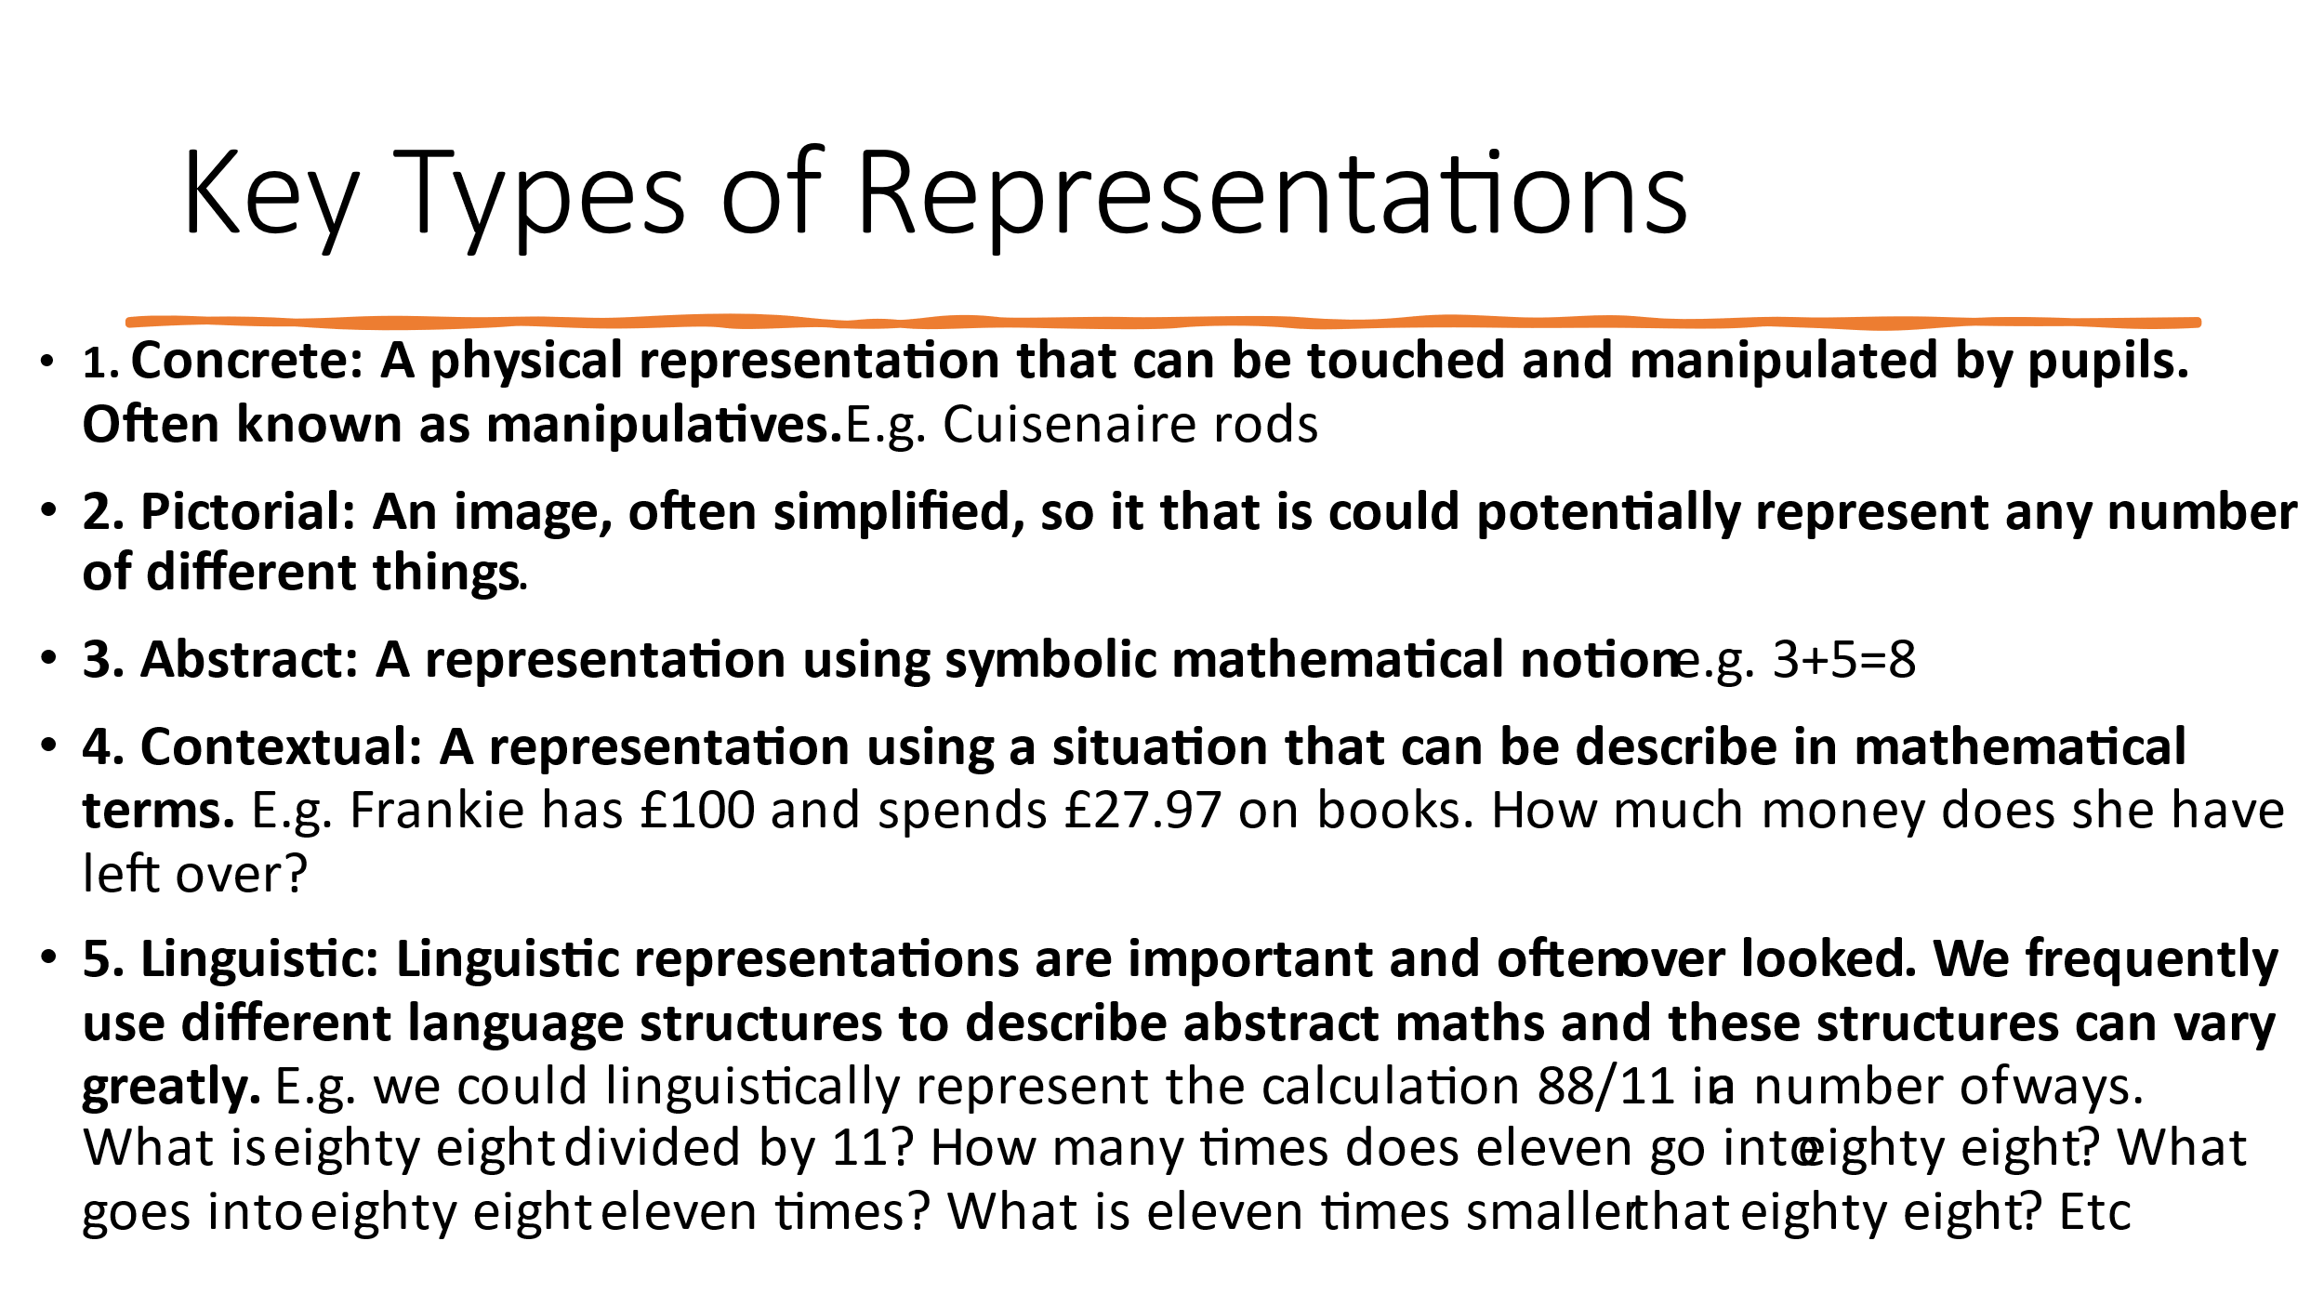
Mathematical language and Sentence Stems

A t St. Michael and All Angels we feel it is important for pupils and teachers to have a common vocabulary and understanding when discussing maths. This is shared across the whole school. By using this mathematically accurate language when the concept is introduced, and not changing the language throughout the years, it avoids unnecessary misunderstandings or misconceptions later. Stem sentences are one method for achieving this in practice.

What is a stem sentence?
A stem sentence is used in a range of topics to provide clarity or to generalise concepts, but it is not a new concept in education. In maths, stem sentences include accurate mathematical vocabulary in a highly structured sentence that provides pupils with a way to communicate their ideas with mathematical precision as well as clarity.

Stem sentences in maths
Stem sentences can be used to:
- Express a key concept
- Generalise a key concept
- Provide a template for discussions or explanations
Each time learners repeat a stem sentence correctly, it helps embed the concept.

How to use a sentence stem
Repetition is a key part of using stem sentences in the classroom. We use an ‘I say, you say, we say’ system.
First, the teacher introduces the stem sentence, ensuring that the learners actually understand what the stem sentence means. They will then say the stem sentence (I say), tell the pupils to repeat the stem sentence (you say), and finally say the stem sentence with the whole class (we say).
This helps pupils to understand that the stem sentence is an important part of the lesson and how to say it correctly. Missing parts can be completed in different ways to show examples of how the stem sentence is used. The appropriate stem sentence should then be referred to throughout the lesson (or maths lessons to come).
It is essential that pupils actually use and understand the stem sentence as a regular part of their learning and to promote meaningful conversation in the classroom. The teacher should also model using stem sentences whenever appropriate.

Why is a whole school approach important?
Learning requires pupils to build upon what they already know. You cannot start teaching a child addition if they do not have a strong understanding of number, just as you cannot teach reading without an understanding of letters.
A whole school approach to stem sentences will benefit pupils in two ways; they will use accurate mathematical language from an early age, and they will become familiar with the use and format of stem sentences. By using mathematically accurate language from a young age, learners should become more confident with the specific terms and their meanings, as well as improve their overall mathematical language proficiency.
Some stem sentences may appear simple, but by understanding how to use the stem sentence, the pupil can apply it to more complex learning.
See our Sentence stems and vocabulary documents

Fluency
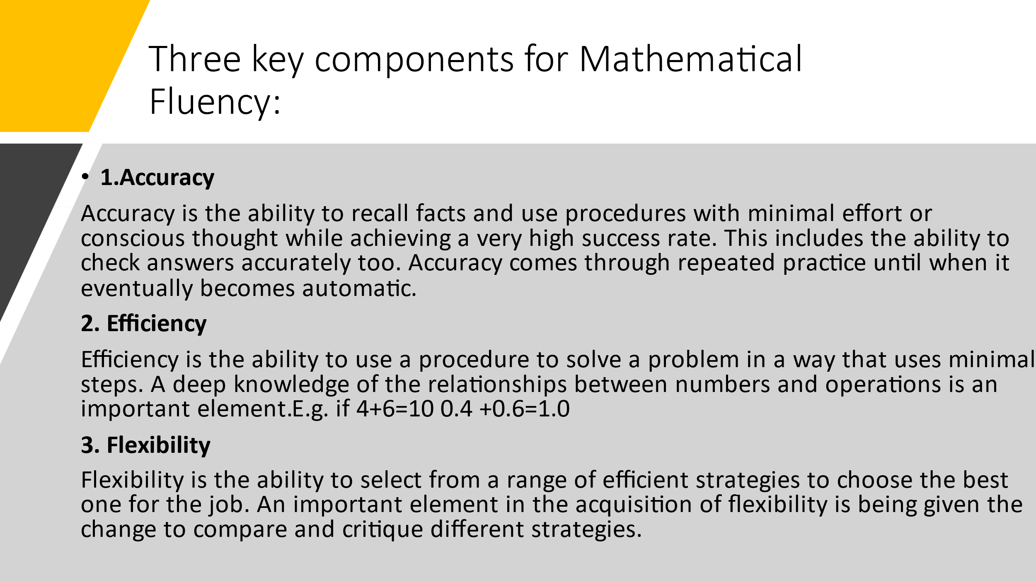
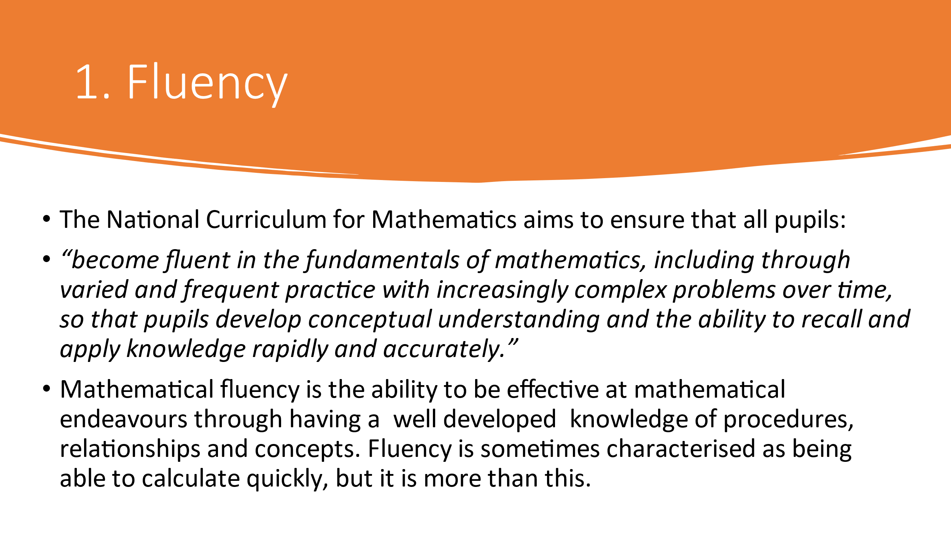
See our progression in basic skills document.

Progression in Times tables
By the end of the year:

Demonstration of the approach to teach times tables:

Times Tables in 10 minutes - YouTube

Years 1: Times tables 1 (13 multiplication facts)
Years 2: Times tables 2, 5 and 10 including division facts. (33 multiplication facts)
Year 3: Times tables 2, 5 10, 3, 4 and 8 including division facts. (21 multiplication facts)
Year 4: All times tables including division facts (12 X12) (15 multiplication facts)
Years 5 and 6: Targeting of individual children.
Within Key stage 2 children develop fluency and variation of times tables based on known facts as appropriate to year group expectations for the multiplication
E.g.
4 X 3 =12
So
40 x 3 =120
4 x 30 = 120
400 x 3 = 1200

For years 5 and 6
0.4 x 3 = 1.2
4 x 0.3 = 1.2
0.004 x 3 = 0.12 etc.

Representations used by Year Group (* INDICATES USE)

 | Tens Frame | Part Whole | Sticks and Dots | Number Lines | Place Value | Bar Models
EYFS | * | *
Y1 | * | * | * | *
Y2 | * | * | * | * |  | *
Y3 | * | * | * | * | * | *
Y4 | * | * | * | * | * | *
Y5 | * | * | * | * | * | *
Y6 | * | * | * | * | * | *
Manipulatives used in School

Maths manipulatives refer to the hands-on resources used in maths classrooms to develop children’s understanding of mathematical concepts, often in a practical, tactile way. Initially, children will need a lot of support and guidance on which manipulatives to select and how to use them. Over time, children can be guided towards making their own choice of manipulatives - this allows them to take ownership of their own learning and development.

Please see our manipulatives document for information on the ones used in school.
Year 1 Addition
Objective | Concrete |  | Pictorial | Abstract
Combining two parts to make a whole – part, part, whole. | Use of cubes or other manipulatives. |  | Simple pictures or symbols to represent numbers.
Starting with the bigger number and counting on. | Starting with the bigger number and counting on 1 by 1. |  | 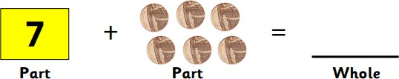  Larger part identified.  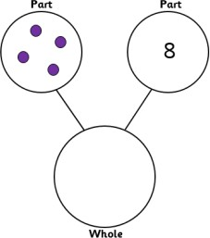 | 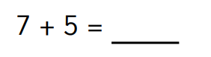  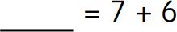
Regrouping to make 10. | Start with bigger number and use number bonds to make ten. |  | 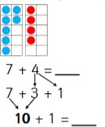 | 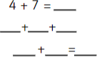
Year 2 Addition
Addition of 1 digit number to a 2-digit number | Use of base ten, tens frames and straws. | 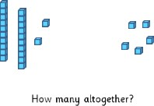 |  | 54 + 4 =
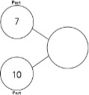
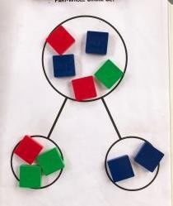
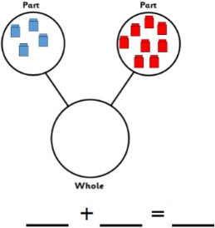
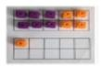
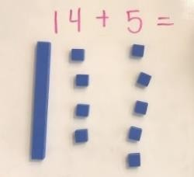

 |  | 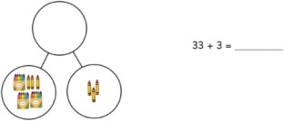
Adding multiples of ten to a 2-digit number. | 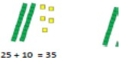 | 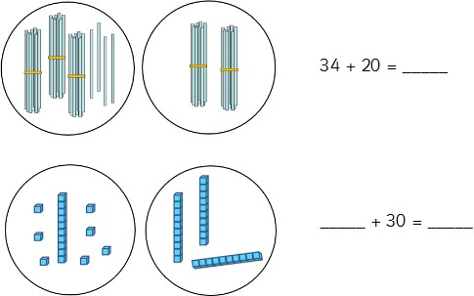 | 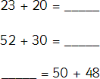
Addition of two 2-digit numbers (without bridging 10) | Use of base 10 and stick bundles | 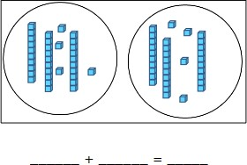 | 23 + 13 =  23 + 10 + 3 =  33 + 3 = 36
Addition of 1 digit number to a 2-digit number (bridging 10)  Exchanging  NB – children need to know and be secure that 10 ones can be represented by a ten – bundle or rod) | 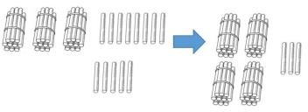  Use of manipulatives (straws, tens frames and base 10)  Regroup of ten. | 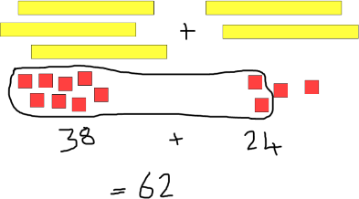  Children to draw the regrouped ones to form a ten then add the remaining ones.
Addition of three single digit numbers | 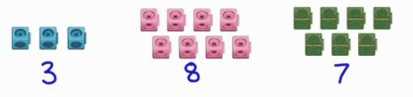  Children to form groups of ten first and then add third number. | 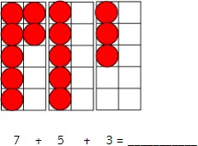 | 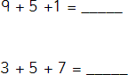
Year 3 Addition
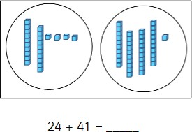

Column addition without exchange | 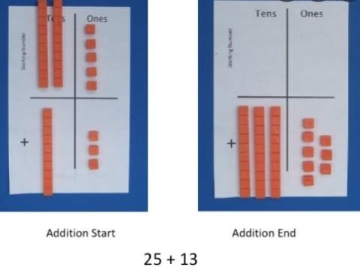  Moving onto use of place value counters | 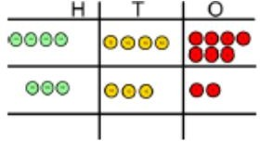  Display the column written method alongside the place value chart representation. | 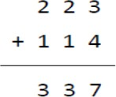  Adding the ones then the tens and then the hundreds.
Column addition with exchange | 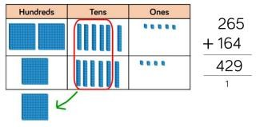  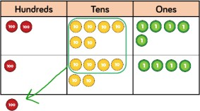 | As concrete model using printed place value charts and children representing numbers on charts with circles. | 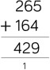
Year 4 to 6 Addition
Addition of two 4-digit numbers or greater. | Children will continue to add increasingly larger numbers as per year 3 guidance Year 4 – up to four digits.  Year 5 and 6 - more than four digits.

Adding decimals | 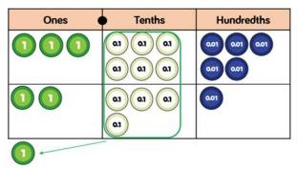  Use of place value charts | 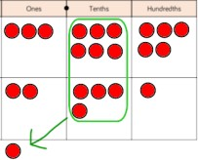  Drawing own representations | 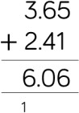  When adding numbers with different amounts of decimal places, ensure that place holders are included.  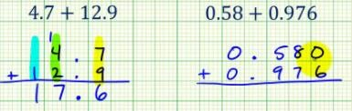

Year 1 Subtraction
Objective | Concrete | Pictorial | Abstract
Taking away ones  (Link with addition and number bonds used in part whole models to show inverse) | Physical objects removed from a whole.  Use of tens frame and part whole model.  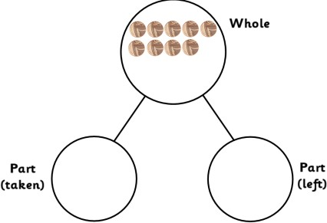 | 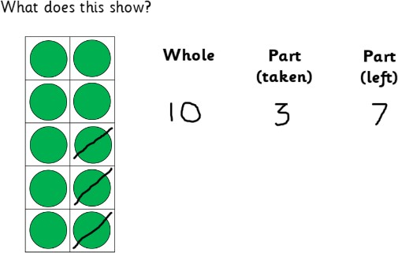  Crossing out of the part to be taken away.  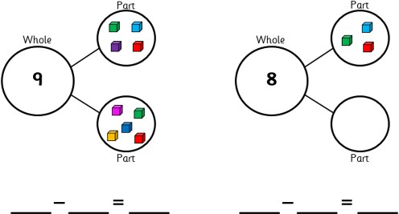  Link to part whole model as inverse of addition. | 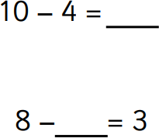
Making 10 | 14 – 6 =  Take away the four to make ten  and then the other two counters. | 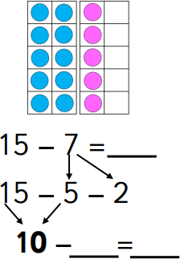 | 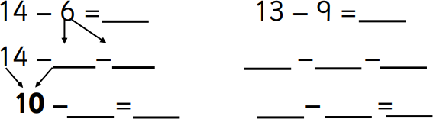
Year 2 Subtraction
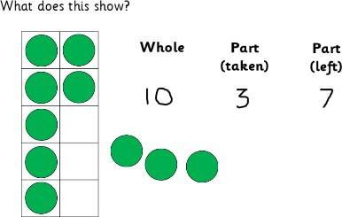
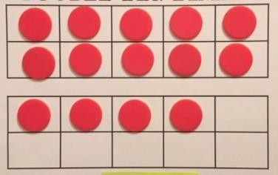

Subtracting a 1-digit or 2-digit number from a 2-digit number without exchanging | 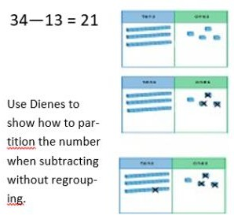 | 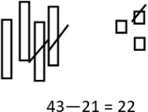  Children to draw their own representation of base ten.
Subtracting using exchange | 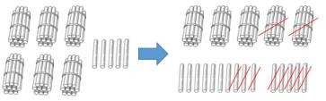  Children to be made aware that bundles may need to be separated to be able to subtract.  This moves on to the use of base 10 equipment.  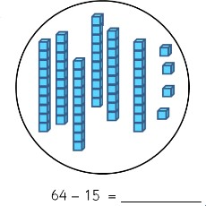 | 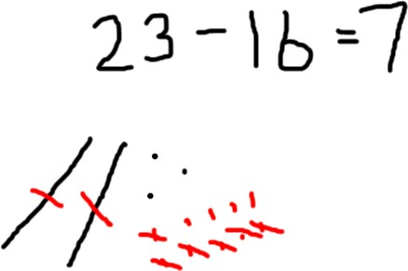  Children to draw their own representation of base ten and then cross out accordingly. | 23 – 16 = 7
Year 3 Subtraction

Subtraction without exchange | 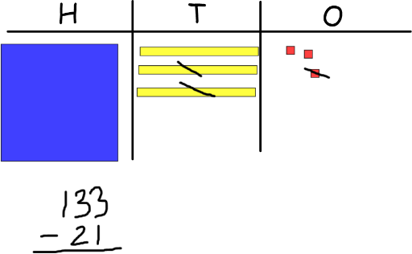  Children to use base 10 and place value charts and then move on to the place value counters. |  | 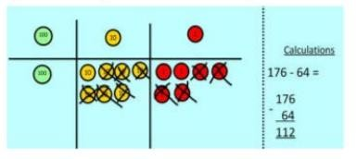 | 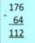
Subtraction involving exchange | 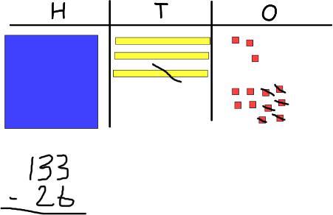  Children to use base 10 and place value charts and establish concept on exchange  then move on to the place value counters. |  | 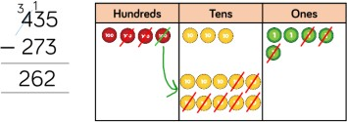  Draw own representations to support calculation. | 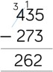
Year 4-6 Subtraction
Subtraction of two 4-digit numbers or greater. | Children will continue to subtract increasingly larger numbers as per year 3 guidance Year 4 – up to four digits  Year 5 and 6 - more than four digits.
Subtracting decimals | 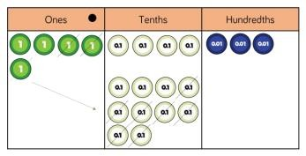  Use of place value charts | 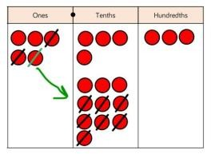  Draw own representation |  | 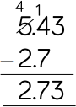

Year 1 Multiplication
Objective | Concrete | Pictorial | Abstract
Doubling | 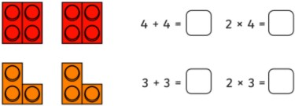  Use of manipulatives to demonstrate doubling | 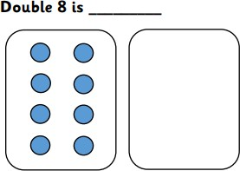  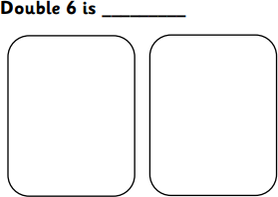 | 8 x 2 =  6 x 2 =
Making equal groups and counting the total. | 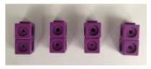  Use manipulatives to make equal groups and then count up | 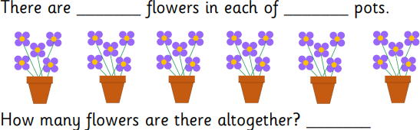 | 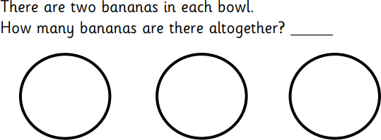  3 x 2 =

Repeated addition | 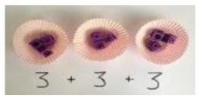  Different objects used to add equal groups | 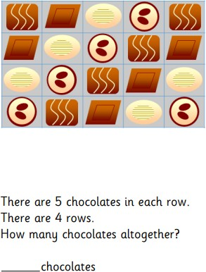 | 5 x 4 =  5 + 5 + 5 + 5 =
Use of arrays | Use manipulatives to create arrays to represent multiplication then count. | 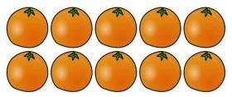  5 x 2 = | 5 x 2 =
Year 2 Multiplication
Doubling | Physical doubling with objects to represent a single digit moving to two-digit numbers using base 10.  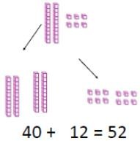 | Draw representations of their own to show the doubling and use of sticks and dots to represent base 10. | 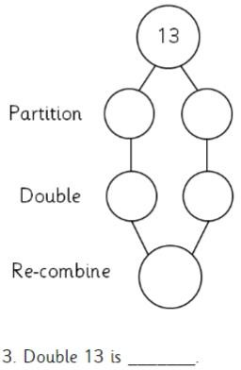  Moving onto: Double 23 and 23 x 2=
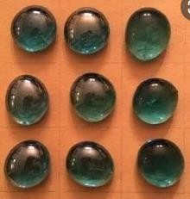

Use of arrays to show that multiplication is commutative | 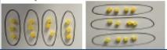  Creating arrays using counters or other objects. | Explore arrays to create calculation and show the commutativity. | 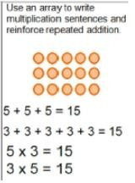
Year 3 and 4 Multiplication
Multiplication of 2- and 3-digit number by a single digit  (Year 3 – 2 digits by 1 digit)  (Year 4 – 3 digits by 1 digit) | 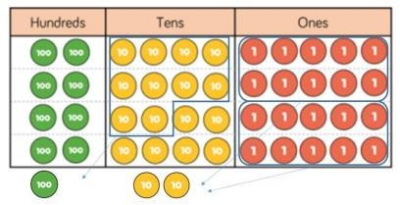  Use of place value chart using base ten or counters forming the array and then adding from the ones  This builds to the grid method  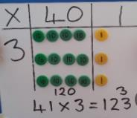 | 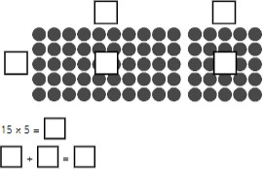  Moving to  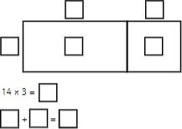 | 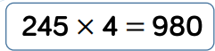  Using formal column method  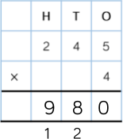
Year 5 and 6 Multiplication
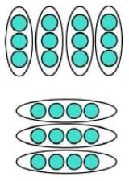

Multiplication of 4-digit number by single digit  This method to also be used when multiplying decimals | 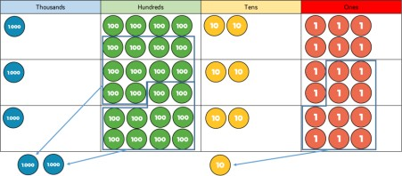  1826 x 4 =  Children to create own array using place value counters on place value chart. | Own representation on place value chart with formal column method alongside. | 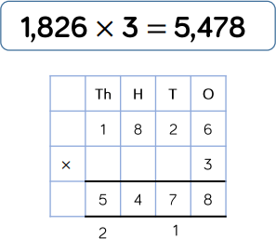
Multiplying a 2-digit number by a 2-digit umber | 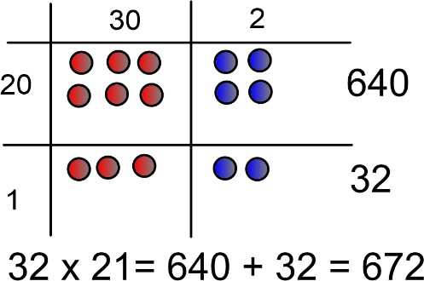  Use of counters on a grid | 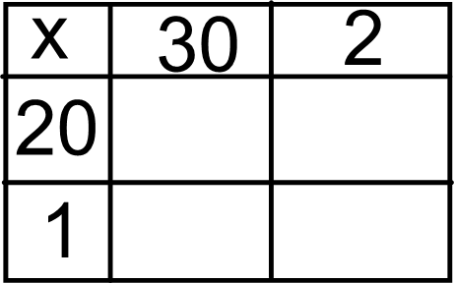 | 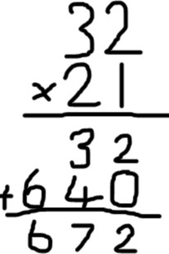
Multiplying a 3-digit number by a 2-digit number | 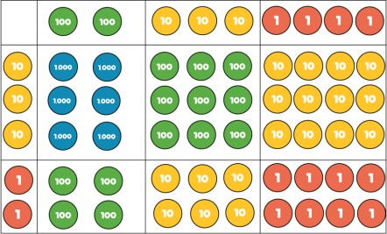  Use of counters on grid (Values can be written as numerals rather than place value) | 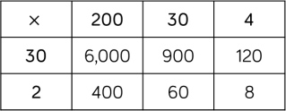 | 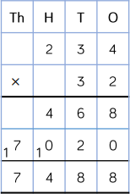

Year 1 Division
Objective | Concrete | Pictorial | Abstract
Division as sharing into equal groups (halving) | Physical sharing into equal groups of manipulatives | 8 ÷ 2 = | 8 ÷ 2 =
Division as grouping | 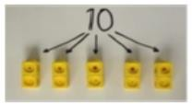 | Physically draw a ring around the group size then count the number of groups | 22 ÷ 2 =
Year 2 Division
Division as sharing with a remainder | Children to physically share an amount between pots | Children to draw and cross out.  when sharing.  Children to move onto drawing own  representations | 13 ÷ 4 =
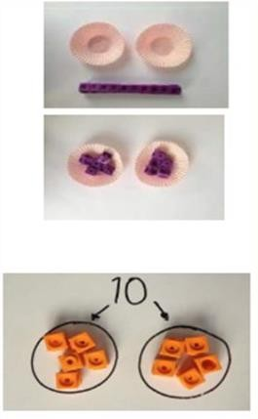
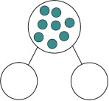
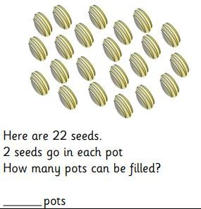
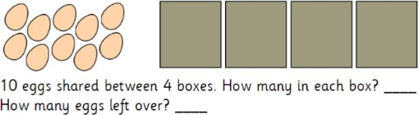

Division as grouping no remainder | 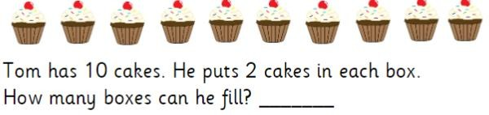  Children to physically draw around the groups. | As concrete method.  Children draw their own representations.  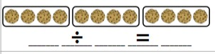
Division as an array | Children to have the arrays to then group.  Children to understand the inverse link to multiplication. | 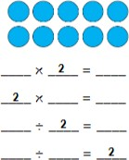
Year 3- 6 Division
The principles apply for division for Years 3 to 6 with ever increasing numbers: Year 4 – 3 digits by 1 digit.
Year 5 and 6 – 4 digits by 1 digit
Division by sharing with exchange | Use of place value charts and base ten and counters physically moving counters and exchanging | Develop own representations using place value charts.  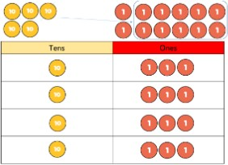 | Chunking method
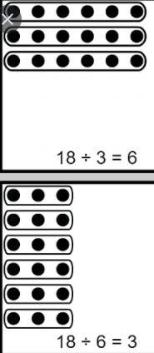
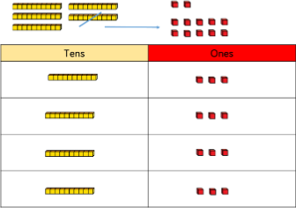

Division by grouping with exchange | 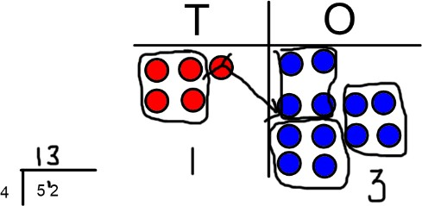  Use of place value charts | As previous with children drawing own representation.
Division by sharing with exchange and remainders | Use of place value charts and base ten and counters physically moving counters and exchanging  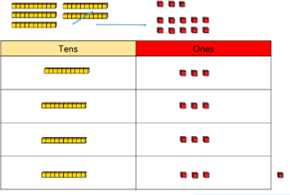 | 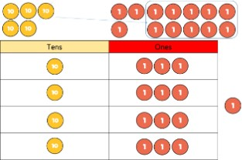  Develop own representations using place value charts | 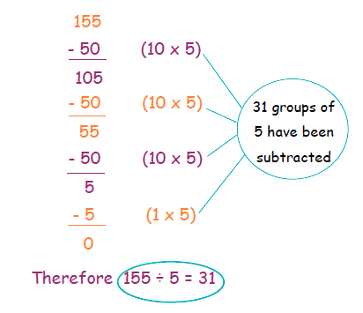
Division by grouping with exchange and remainders | 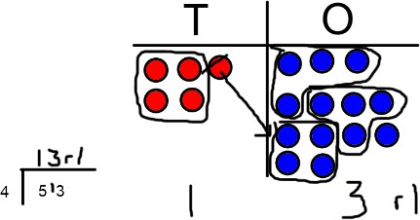  Use of place value chart | As previous with children drawing own representation. | 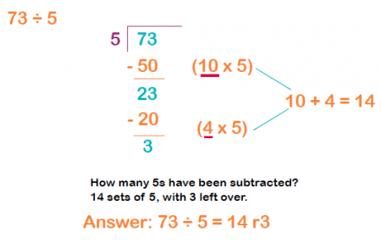

Year 6 Division
Division of multiple digits by a 2-digit number.  (Long division) | Concrete resources will not help this skill. | Pictorial representation do not help this skill but the writing of key multiple facts will provide a scaffold for children to use. | 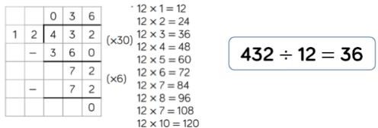
Division of multiple digits by a 2-digit number.  (Short division) | Concrete resources will not help this skill. | Pictorial representation do not help this skill but the writing of key multiple facts will provide a scaffold for children to use. | 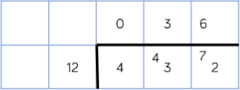  Children to move to short division method as soon  as possible to reduce the need for subtraction where mistakes could  arise.

